

**Tribhuvan University**

Faculty of humanities and social science

**Bhaktapur Multiple Campus**

A lab report

On

Computer Fundamentals and its applications

**Submitted By:**

“Sujan Tamang”

“BCA” “B”

**Submitted To:**

Asst.Lec Madan Nath

Faculty of humanities

**Table of Contents**

**Acknowledgement** i

**List of Abbreviations** ii

**List Of Tables** iii

**List Of Figures** iv

**Chapter 1: Microsoft Word** - 1 -

**1.1** **Lab1: Class Routine** - 2 -

**1.2** **Lab2: Curriculum Vitae (CV)** - 3 -

**1.3** **Lab3: Invitation Card** - 4 -

**1.4** **Lab4: Mail Merge** - 5 -

**1.4.1 Mail Merge Message** - 10 -

**1.5** **Lab5: WordArt** - 10 -

**1.6** **Lab6: Water Mark** - 12 -

**1.7** **Lab7: Thesaurus** - 13 -

**1.8** **Lab8: Citation** - 14 -

**1.8.1 Creating a Bibliography** - 16 -

**Lab9: Shortcut Keys** - 18 -

**Chapter 2: Microsoft PowerPoint** - 19 -

**2.1 Lab8: Inserting new slides** - 20 -

**2.2 Lab9:Animations** - 21 -

**2.3 My Presentation** - 22 -

**Chapter 3: Microsoft Excel** - 30 -

**3.1 Some Formulas in Excel** - 31 -

**3.1.1 SUM** - 32 -

**3.1.2 AVERAGE** - 33 -

**3.1.3. COUNT** - 33 -

**3.1.4 SUBTOTAL** - 34 -

**3.1.5 MODULUS** - 35 -

**3.1.6 POWER** - 36 -

**3.1.7 CEILING** - 36 -

**3.2 Marksheet in Excel** - 37 -

**Chapter 4: MS Dos** - 41 -

**4.1 Fun Commands** - 42 -

**4.1.1 Title** - 42 -

**4.1.2 Prompt** - 43 -

**4.1.3 Color** - 43 -

**4.2 Some Internal Commands** - 44 -

**4.2.1 CLS** - 44 -

**4.2.2 Date and Time** - 45 -

**4.2.3 Md or mkdir** - 45 -

**4.2.4 Copy** - 46 -

**4.2.5 Type and echo** - 47 -

**4.2.6 Ren or Rename** - 47 -

**4.2.7 dir** - 48 -

**4.2.8 del** - 48 -

**4.2.9 RD** - 49 -

**4.2.10 vol and ver** - 49 -

**4.3 Some External Commands** - 50 -

4.3.1 Format - 50 -

**4.3.2 DISKCOPY** - 50 -

**4.3.3 XCOPY** - 50 -

**4.3.4 CHKDSK** - 50 -

**4.3.5 TREE** - 51 -

**4.3.6 More** - 51 -

**4.3.7 ATTRIB** - 51 -

**Chapter 5: Photoshop** - 52 -

**5.1 Tools in Photoshop** - 52 -

**5.1.1 Move tool** - 52 -

**5.1.2 Rectangular Marquee tool** - 54 -

**5.1.3 Lasso Tool** - 55 -

**5.1.4 Crop Tool** - 56 -

**5.1.5 Object Selection Tool** - 57 -

**5.1.6 Frame Tool** - 58 -

**5.1.7 Eyedropper Tool** - 59 -

**5.1.8 Patch Tool** - 61 -

**5.1.9 Brush Tool** - 62 -

**5.1.10 Clone Stamp Tool** - 63 -

**5.1.11 History Brush Tool** - 65 -

**5.1.12 Eraser Tool** - 67 -

**5.1.13 Gradient Tool** - 68 -

**5.1.14 Blur Tool** - 69 -

**5.1.15 Dodge Tool** - 70 -

**References** - 72 -

# **Acknowledgement**

First and foremost, I am grateful to Bhaktapur Multiple Campus for providing the necessary resources and facilities for the successful execution of this project. Their support has been crucial to its completion.

I would like to thank **Mr. Madan Nath** for his guidance, mentorship, and unwavering support throughout this project. His expertise and insights have been instrumental in shaping the direction of this work.

I would like to express my sincere gratitude to all those who have contributed to the completion of this project. Their support and assistance have been invaluable throughout the process.

Thank you to everyone who has contributed to this project in any way. Your support has made a significant difference, and I am truly grateful.

Sujan Tamang

# 

# **List of Abbreviations**

CV Curriculum Viate

DOS Disk Operating Sytem

OS Operating System

# **List Of Tables**

Table 1:ClassRoutine - 2 -

Table 2: Teachers Contact and their respective subject - 2 -

# **List Of Figures**

**Figure 1:Ms Word** - 1 -

**Figure 2:Ms Excel** - 31 -

# **Chapter 1: Microsoft Word**

Microsoft word is a word processor software developed by Microsoft in 1983. It is the most commonly used word processor software. It is used to create professional quality documents, letters, reports, resumes, etc. and also allows you to edit or modify your new or existing document. The file saved in Ms Word has .docx extension. It is a component of the Microsoft Office suite, but you can buy it separately and is available for both Windows and macOS.

Now let us discuss the features or components of the Ms Word. Using these features, you can perform different types of operations on your documents, like you can create, delete, style, modify, or view the content of your document.

*Features of MS Word are as follows*:

* Creating and saving file
* Editing and formatting document
* Paragraph formatting

**Figure 1:Ms Word**

* Inserting header and footer and page number
* Checking spelling and grammar
* Subscript and superscript
* Inserting symbols
* Print preview and printing
* Page setting
* Bullets and number
* Border and shading
* Searching a word and replacing it by another word
* Inserting tables

## **Lab1: Class Routine**

**Bhaktapur Multiple Campus**

**Dudpati- 1, Bhaktapur**

**Class Routine for BCA Program 2080 batch, 1st Semester (Section – B)**

Effective from: 2080-08-10

**Table 1:ClassRoutine**

|  |  |  |  |  |  |  |
| --- | --- | --- | --- | --- | --- | --- |
| **Day/Time** | **11:00-12:00** | **12:00-1:00** | **1:00-2:00** | **2:00-2:30** | **2:30-3:30** | **3:30-4:30** |
| **Sunday** | **English-I** | **Society and Technology** | **Mathematics-I** | **BREAK** | **Digital Logic** | **Computer Fundamental and Applications** |
| **Monday** | **English-I** | **Society and Technology** | **Mathematics-I** | **BREAK** | **Digital Logic** | **Computer Fundamental and Applications** |
| **Tuesday** | **English-I** | **Society and Technology** | **Mathematics-I** | **BREAK** | **Digital Logic** | **Computer Fundamental and Applications** |
| **Wednesday** | **English-I** | **Society and Technology** | **Mathematics-I** | **BREAK** | **Digital Logic** | **Computer Fundamental and Applications** |
| **Thursday** | **English-I** | **Society and Technology** | **Mathematics-I** | **BREAK** | **Digital Logic** | **Computer Fundamental and Applications** |
| **Friday** | **English-I** | **Society and Technology** | **Mathematics-I** | **BREAK** | **Digital Logic** | **Computer Fundamental and Applications** |

**Table 2: Teachers Contact and their respective subject**

|  |  |  |  |
| --- | --- | --- | --- |
| **Subject Code** | **Subject** | **Name of Lecturer** | **Contact No** |
| **CACS 101** | **Computer Fundamental and Applications** | **Mr. Madan Nath** | **9848763868** |
| **CACO 102** | **Society and Technology** | **Mr. Dhruba Laudari** | **9846062115** |
| **CAEN 103** | **English – I** | **Mrs. Prativa Prajapati** | **9841754578** |
| **CAMT 104** | **Mathematics – I** | **Mr. Sher Singh Rajkhola** | **9851191272** |
| **CACS 105** | **Digital Logic** | **Mr. Ramdhir Kumar Yadav** | **9849521113** |

………………………………………

**Program Coordinator**

## **Lab2: Curriculum Vitae (CV)**

***Summary***

*Dedicated and enthusiastic bachelors’ student with a strong academic background and a genuine passion for learning new things. Well-versed in various fields, particularly in (Programming). Demonstrated leadership and communication skills through active participation in school clubs and volunteer work. Possess a patient and supportive approach to help others succeed.*

**Sujan Tamang**





**+977 9762447050**

[**Suzanyba079@gmail.com**](mailto:Suzanyba079@gmail.com)

**Bhaktapur, Nepal**



***Training and Experience***

* ***First Aid***

*I have got the red cross first aid training in my school level. During that time I have learned various emergency first aid techniques that can save one’s life in case of emergency.*

* ***Scouting***

*I have been in scout for 4 years. During that period I have got many experiences like camping, Survival skills, knots skills, adventures etc.*

***Skills***

* **Communication**
* **Organizing**
* **First Aid**
* **Handy Crafts**

***Hobbies***

* **Guitaring**
* **Art and Crafts**
* **Sleeping**
* **Doing Nothing**

***Education***

***Bhaktapur Multiple Campus, Dudpati***

*2080 - Present*

*Bachelors of Computer Application*

***Khwopa Secondary School, Dekocha***

*2078/79*

*10+2 Management ( CS )*

***Himchuli Academy, MadhyapurThimi***

*2077*

*Secondary Evaluation Examination(SEE)*

***Language***

* **English**
* **Nepali**

## **Lab3: Invitation Card**





**Invitation Card**

**Save The Date**

**Mr. and Mrs. Tamang**

TOGETHER WITH THEIR LOVING FAMILIES

"Join us for an unforgettable evening! awaits you and make memories with us!"

THIS THAT STREET 123

BHAKTAPUR,NEPAL

5 PM ONWARDS

**WEDNESDAY -1- JAN 2036**

## **Lab4: Mail Merge**

Email merge works exactly same as a standard mail merge….expect for one big difference. Instead of printing individual letters or envelopes or labels, Microsoft Word will generate individual emails, send them to your outlook outbox, and then when you are next online in outlook, Outlook will send each of your personalized emails to each addressee. [1]

Starting Mail Merge :

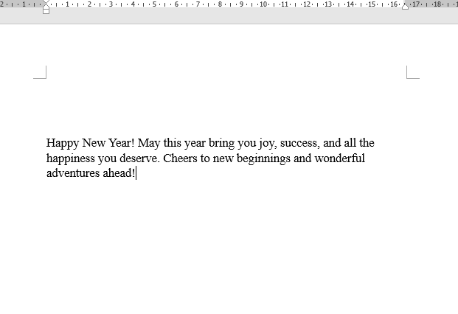

**Step 1:** Open Word Document

**Step 2:** Type your email in word.

**Step 3:** Click on the “Mailing” tab in the ribbon.

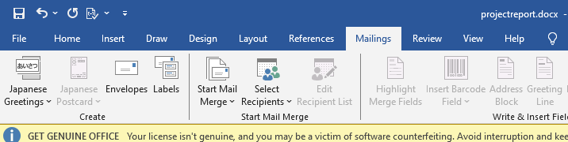

**Step 4:** then click on **“Start Mail Merge”** Button. It will show a list of mail merge options available. You can choose letters, e-mail messages, envelopes, labels or directory.

In this case, as we want to send an email. click on email messages.

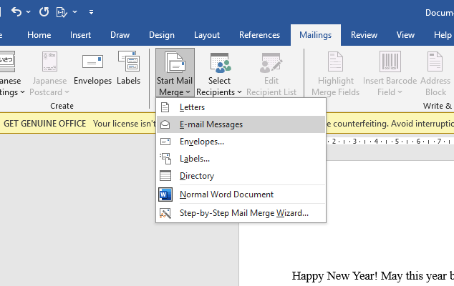

**Step 5:** next you need to select the recipients of your email merge. These names could come from any number or sources.. maybe a Microsoft Excel spreadsheet or you could type them yourself.

To do that click on the “**select recipients**” box in the “start mail merge” group. Either find your data sources form your outlook contacts or create or create a new list.

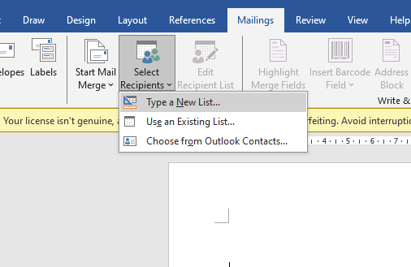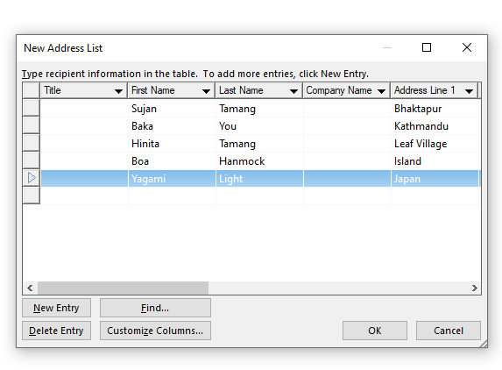

**Step 6:** if you want to edit any of the recipients in the list, now is the time to click on the “**Edit recipients list”** in the “**Start Mail Merge”** group.

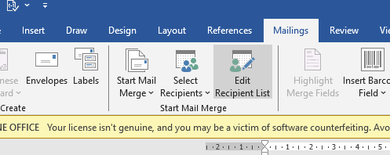

**Step 7:** The next step is to add the appropriate fields to personalize the greeting, the recipient’s name, or to add any other piece of data you might have on the contact anywhere throughout your recipients list.

You can find the appropriate fields in the **“write and insert fields”** group (Still on mailing tab). More than likely, you will want to add at least a greeting line (dear suzan…or something like that). To do that, click on the “Greeting Line” button in the “**writ and insert fields”** group. The following dialog box appears.

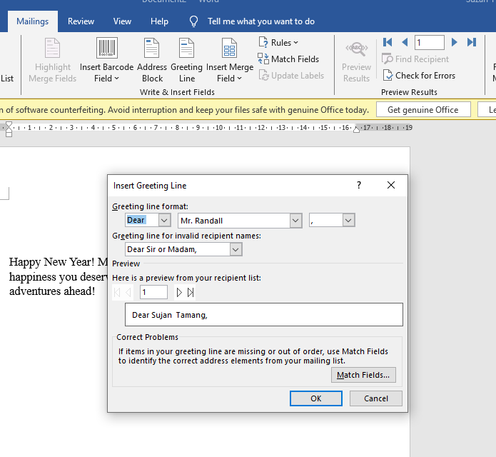

**Step 8:** once you are happy with your greeting line format, click “OK”. Microsoft word will now drop the field into your document.

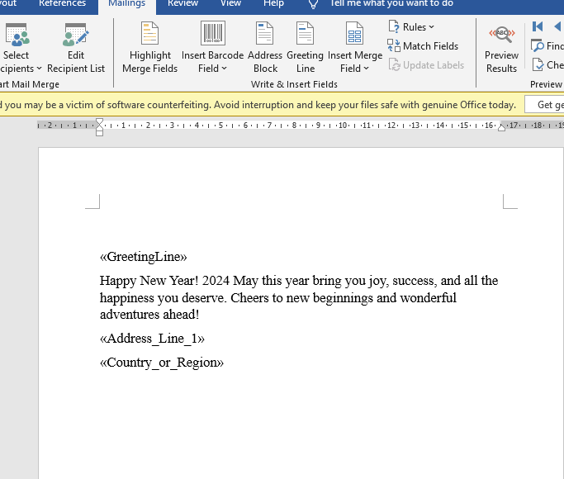

**Step 9:** Now you can preview your results to ensure that everyone’s name is coming up correctly. Click the “Preview Results” button in the “Preview Results” group… then use the forward and back arrows beside it to run through your recipient list.

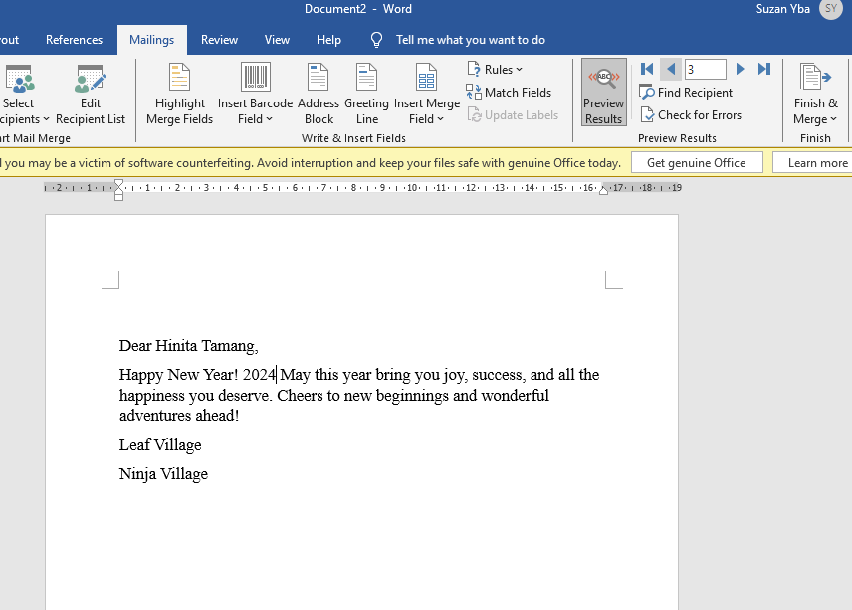

**Step 10:** Now Finish your mail merge and send it.

### **1.4.1 Mail Merge Message**

Dear Hinata Tamang

Happy New Year! 2024 may this year brings you joy, success and all the happiness you deserve. Cheers to new beginning and wonderful adventure ahead!.

Leaf Village

Ninja Village

## **Lab5: WordArt**

**Step 1**: Click **Insert** you will see WordArt option in the text group.

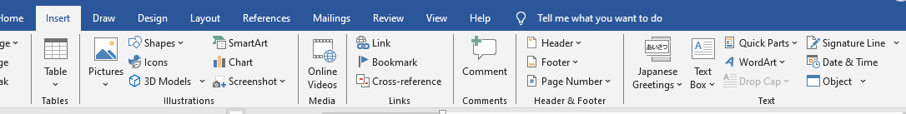

In the WordArt Gallery, You can see different designs that can be applied to your text

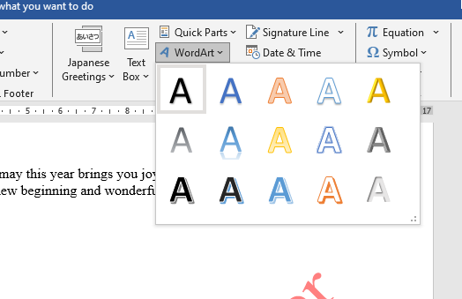

**Step 2:** Select the design you want and the placeholder ”your text here” appears



**SuZanYba**

You can change the text with your own text.

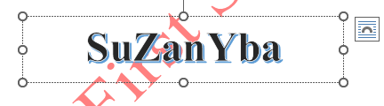

## **Lab6: Water Mark**

**Step 1:** Open a word document.

**Step 2**: Click the Page Layout tab or design tab and then click the Watermark button.

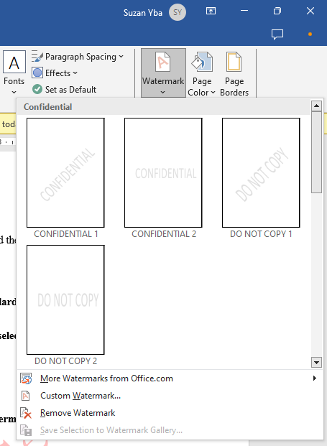

**Step 3**:you can select any of the available watermarks which will be

applied to all the pages of the word.

**You can set Custom Watermark too…. following steps**

**Step 1:**Open a Word document**.**

**Step 2:** : Click the Page Layout tab or design tab and then click the Watermark buttonAt the bottom, you will find the Custom Watermark option.

**Step 3:** Click over the Custom Watermark option; this will display the Printed Watermark dialog box.

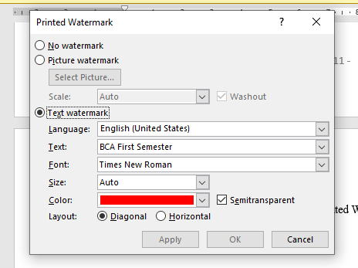

**Step 4 :**Now you can set a picture as watermark or you can set predefined text as watermark; you can alsotype your text in the Text box available at Printed Watermark dialog box. We will set text watermark

## **Lab7: Thesaurus**

**Step 1:** Open your document in Word 2010.

**Step 2:** Locate the word for which you wish to find a synonym, then select it with your mouse.

*Note that you can select a word quickly by double-clicking it.*

**Step 3:** Click the Review tab at the top of the window**.**

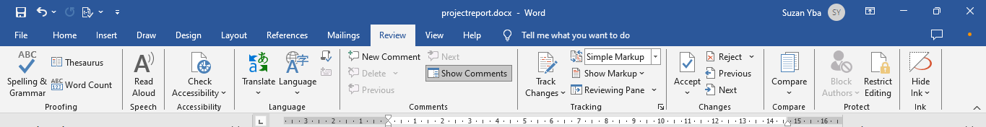

**Step 4:** Click the Thesaurus button in the Proofing section of the Office ribbon.

**Step 5:** Hover your mouse over the word that you wish to use from the column at the right side of thescreen, click the arrow to the right of the word, then click the Insert option.

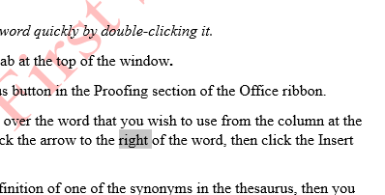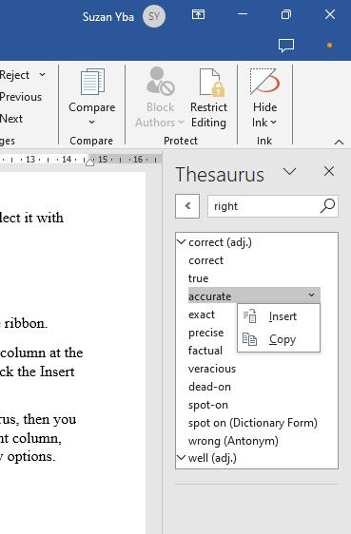

If you are unsure of the definition of one of the synonyms in the thesaurus, then you can click the word to place it in the Search for field at the top of the right column, click the drop-down menu under it, and then select one of the dictionary options.

You will then be able to see the dictionary entry for the selected word.

## **Lab8: Citation**

**Step 1:** Go to the References Tab (left red arrow).

**Step 2:** Click the arrow next to the Citations & Bibliography group.

**Step 3:** Choose the style (right red arrow).

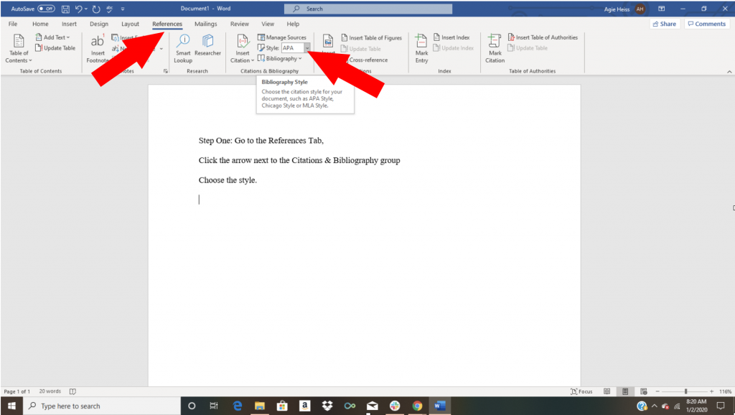

Check to make sure you’re selecting the correct version of each style.

**Step 4:**Click where you want to[**insert a citation**](https://www.bibliography.com/how-to/in-text-and-parenthetical-citations/).

* Go to References Tab (circled in red).
* Click Insert Citation (red arrow).

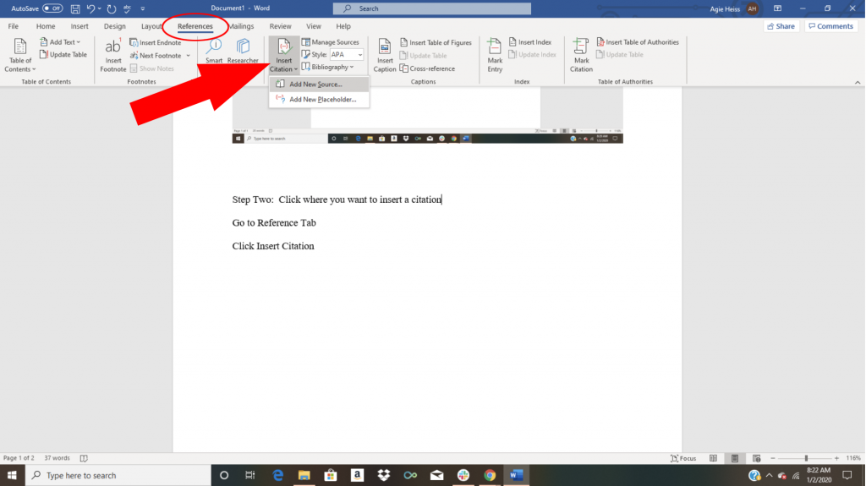

**Step 5:** Add a new source.

* In the Create Source box, select Type of Source.

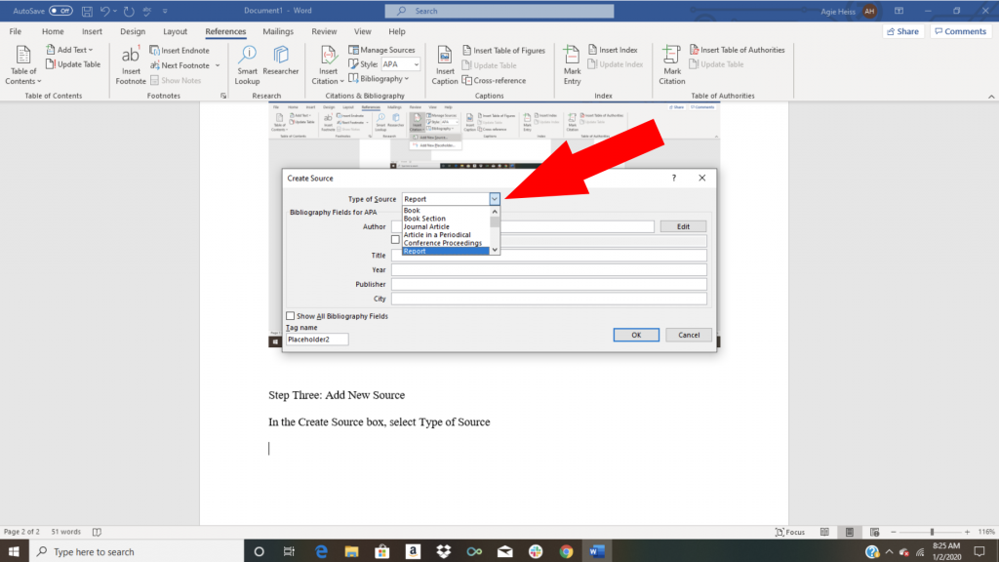

**Step 6:** Enter the details for your new source.

Make sure you’ve entered every detail for the source, including edition, version and publisher.

### **1.8.1 Creating a Bibliography**

Once you’ve entered your sources and you’re ready to create your bibliography, follow these steps:

**Step 1:** Select References in the toolbar.

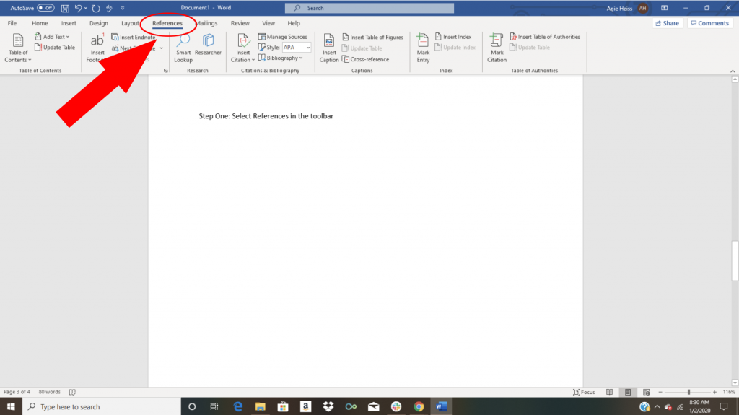

**Step 2:** Go to the Citations & Bibliography Group.

* Select the Bibliography arrow.

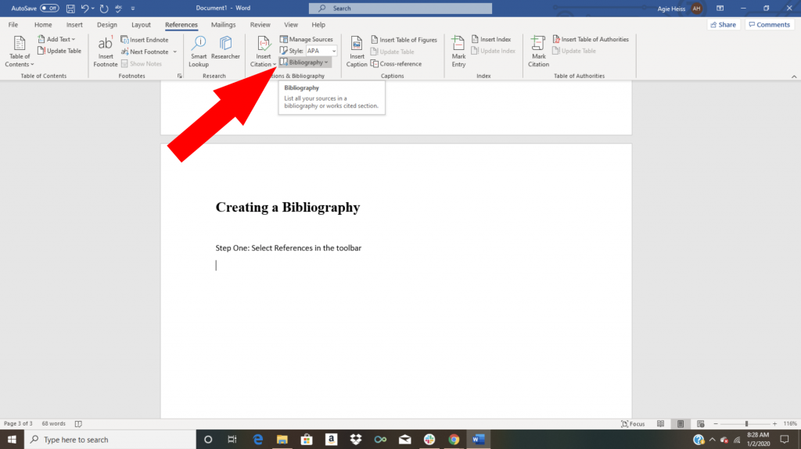

**Step 3:** Choose between a bibliography, references list or works cited list for your preferred format.

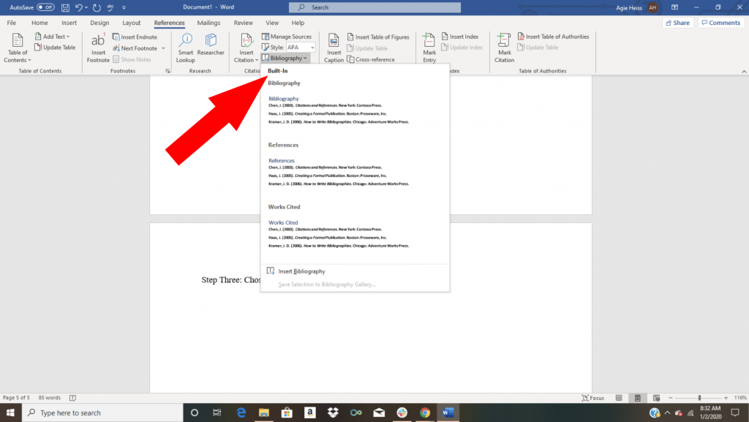

**Step 4:** Select “Insert Bibliography” and your sources will format into a bibliography, works cited or reference list as you’ve selected. [2]

## **Lab9: Shortcut Keys**

Listed down are a few shortcut keys of MS Word:

* **Ctrl + A:** Select all contents of the page
* **Ctrl + B:** Bold highlighted selection
* **Ctrl + C:** Copy selected text
* **Ctrl + X:** Cut selected text
* **Ctrl + N:** Open new/blank document
* **Ctrl + P:** Open the print window
* **Ctrl + I:** Italicise highlighted selection
* **Ctrl + U:** Underline highlighted selection
* **Ctrl + V:** Paste
* **Ctrl + Y:** Redo the last action performed
* **Ctrl + Z:** Undo last action
* **Ctrl + G:** Find and replace options
* **F1:** Open help
* **F7:** Spell check selected text and/or document
* **F12:** Save as
* **Ctrl + S:** Save
* **Ctrl + W:** Close document
* **Alt + Shift + D**: Insert the current date
* **Alt + Shift + T:** Insert the current time
* **Ctrl + Backspace:** Delete word to the left of the cursor. [3]

# **Chapter 2: Microsoft PowerPoint**

Microsoft PowerPoint is a powerful presentation software developed by Microsoft. It's part of the Microsoft Office suite, which includes other popular applications like Word, Excel, and Outlook. PowerPoint is widely used for creating dynamic and visually appealing presentations for various purposes, including business meetings, academic lectures, training sessions, and more.

*Some key features of Microsoft PowerPoint include:*

**Slides**: Presentations are made up of individual slides where you can add text, images, charts, graphs, videos, and other multimedia elements.

**Themes and Templates**: PowerPoint offers a wide range of built-in themes and templates to give your presentations a professional look and feel. You can also create custom themes to suit your specific needs.

**Transitions and Animations:** You can add transitions between slides to create smooth visual effects when moving from one slide to another. Animations can be applied to individual elements within a slide to add emphasis or make your presentation more engaging.

**Collaboration:** PowerPoint allows for easy collaboration with others. Multiple users can work on the same presentation simultaneously, either online or offline, using features like co-authoring and comments.

**Integration:** It integrates seamlessly with other Microsoft Office applications, such as Word and Excel. You can easily import content from these applications into your PowerPoint presentations, and vice versa.

**Presenter Tools**: PowerPoint includes features to assist presenters during presentations, such as presenter view, which shows the current slide, speaker notes, and a timer on the presenter's screen while displaying only the slides to the audience.

**Accessibility**: Microsoft has made efforts to ensure that PowerPoint is accessible to users with disabilities. It includes features like screen readers, alt text for images, and accessibility checker to help users create presentations that are inclusive and comply with accessibility standards.

## **2.1 Lab1: Inserting new slides**

**Step 1:** Open your PowerPoint presentation in a web browser and sign in to your Microsoft account.

**Step 2:** Click on the “Insert” tab located at the top of the PowerPoint window.

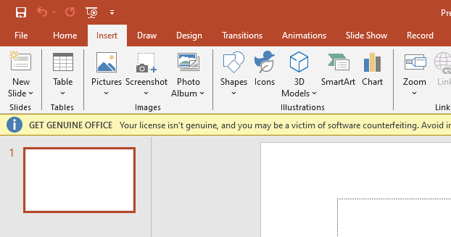

**Step 3:** Click the “New Slide” button in the Slides group on the Insert tab.

A drop-down menu will appear with multiple slide layout options. You can choose the layout for your new slide.

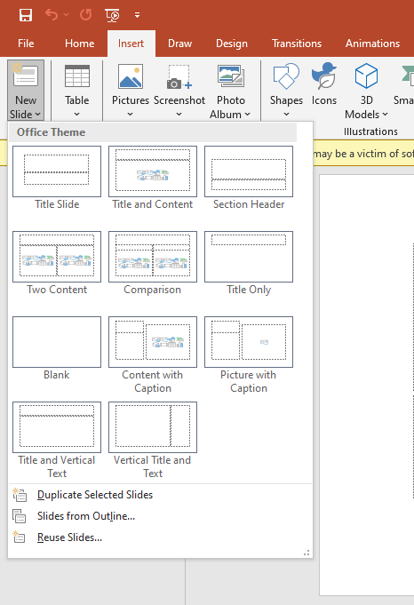

## **2.2 Lab2:Animations**

**Step 1:** Open your PowerPoint presentation and navigate to the slide to which you want to apply animations**.**

**Step 2:** Select the item you want to animate.

**Step 3:** On the Animations tab, in the Animations group, select the More arrow in the Animations box. You can also add Entrance, Emphasis, or Exit animations:

*An Entrance animates the item as it appears on the slide.*

*An Emphasis animates the item after it’s already on the slide.*

*An Exit animates the item as it leaves the slide.*

**Step 4:**Select the animation you want to use. When you select it, you’ll see the animation happen on your slide.

*You’ll see the number “1” appear next to the object you’ve animated, indicating this will be the first animation to occur when you select within the slide during your presentation. If you animate more than one item, they'll be numbered in the order in which you create them.*

**Step 5:** To fine-tune the way animations happen during your presentation, on the Animations tab, in the Advanced Animation group, select Animation Pane. A pane will appear in the right-hand column of your screen.

*To remove an animation, select an animated item, then, on the Animations tab, in the Animations group, select None.*

## **2.3 My Presentation**

This is the presentation on Internet , Intranet, Extranet,

**Slide 1:**



**Slide 2:**



**Slide 3:**

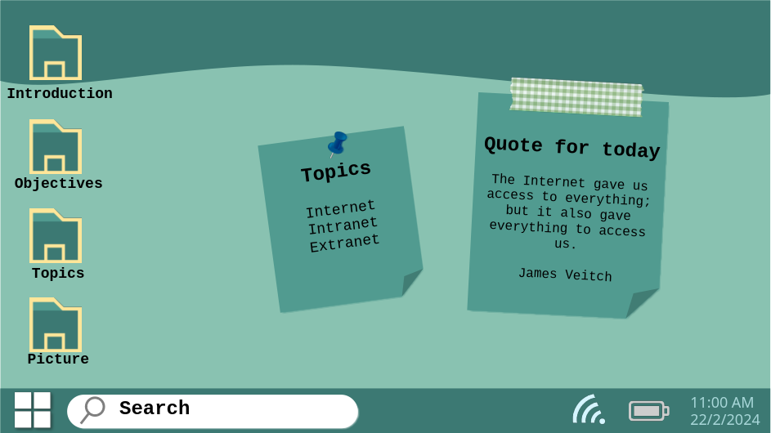

**Slide 4:**

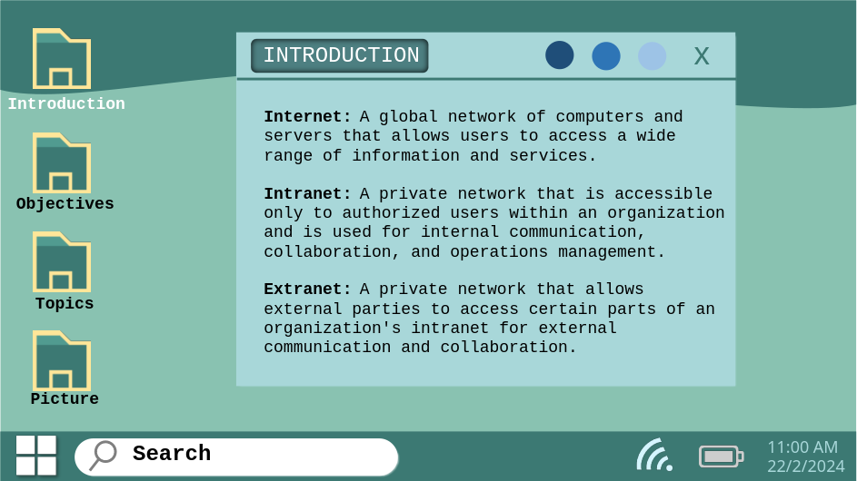

**Slide 5:**

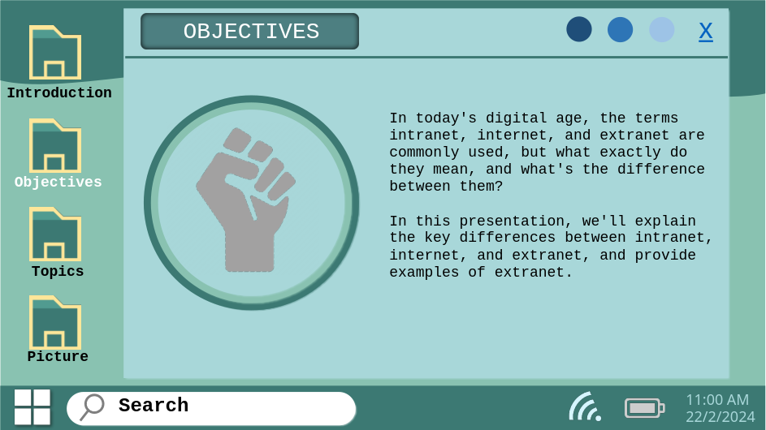

**Slide 6:**

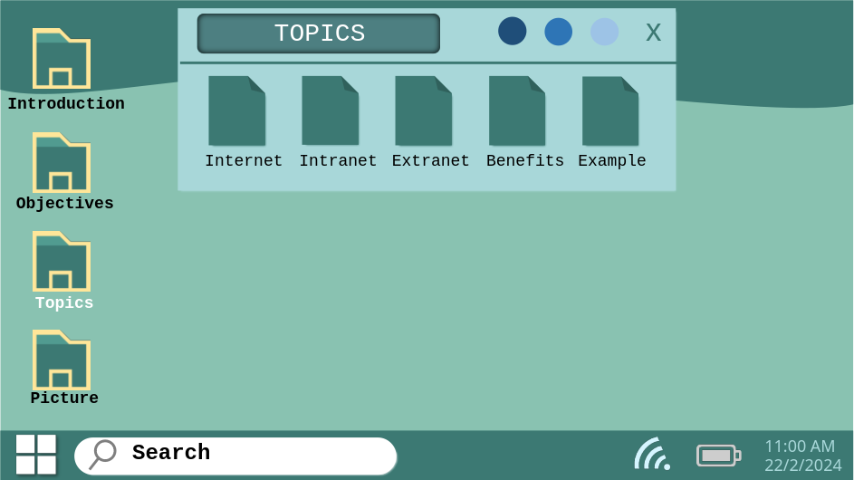

**Slide 7:**

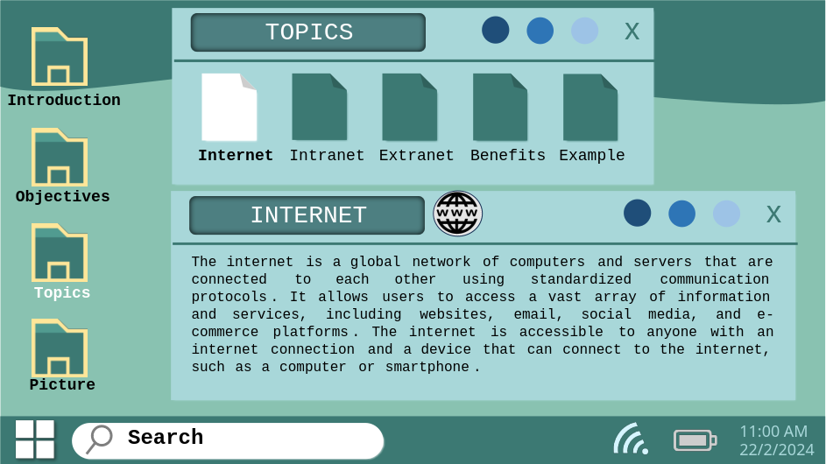

**Slide 8:**

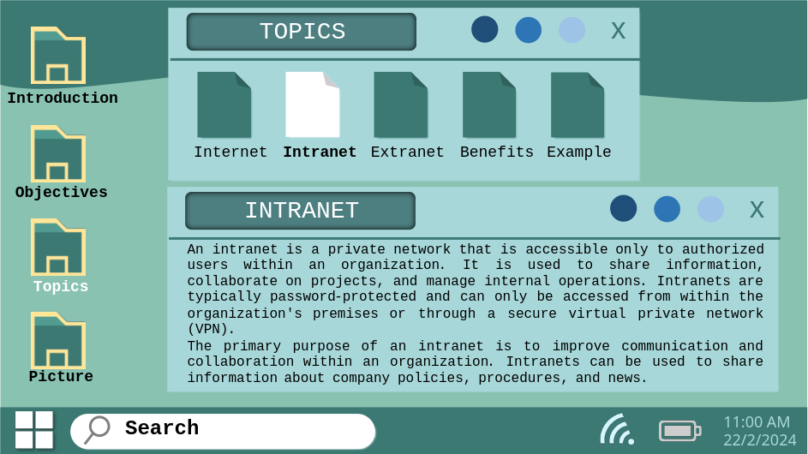

**Slide 9:**

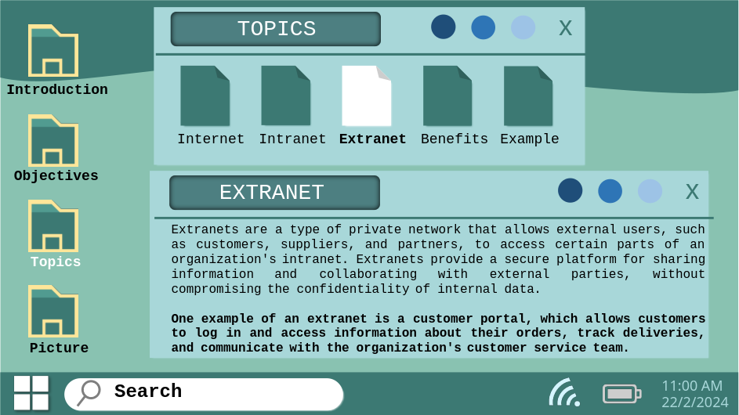

**Slide 10:**

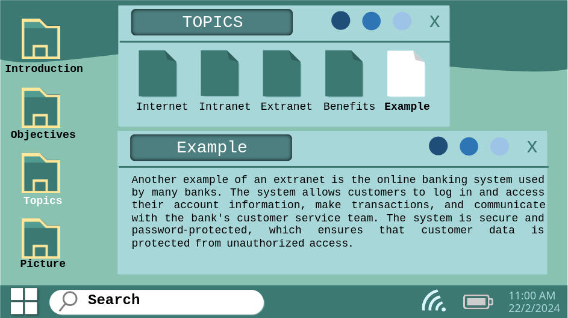

**Slide 11:**

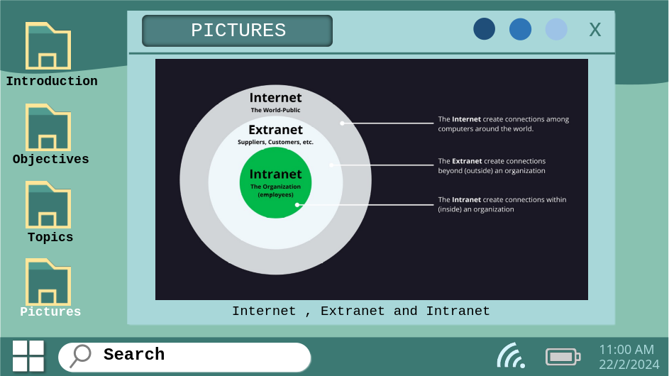

**Slide 12:**

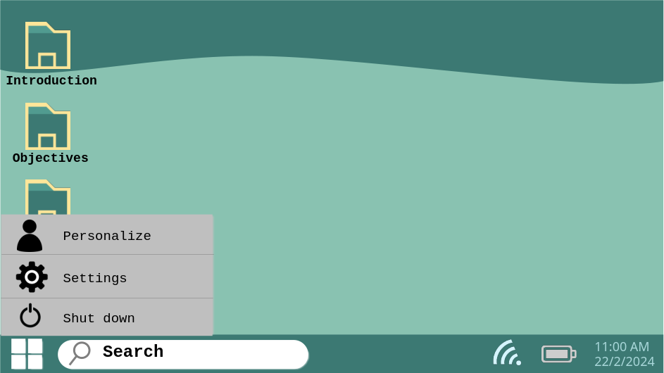

**Slide 13:**

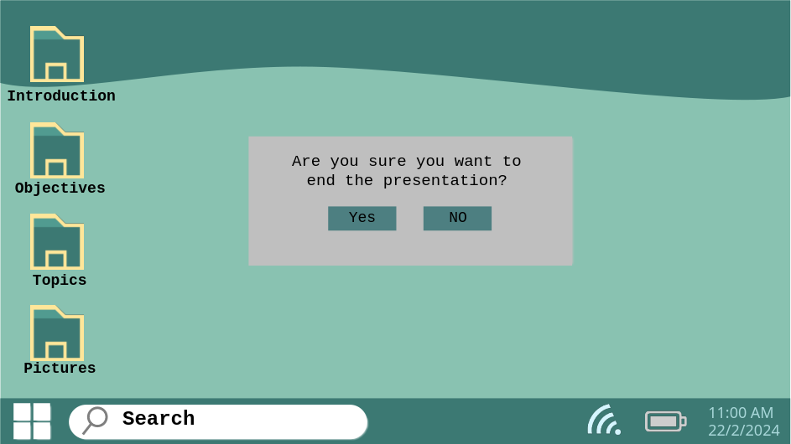

**Slide 14:**



**Slide 15:**

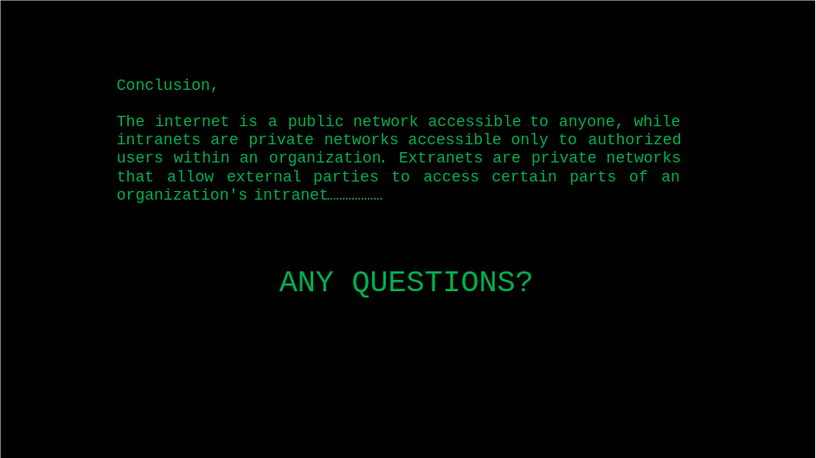

# **Chapter 3: Microsoft Excel**

Microsoft Excel is a powerful spreadsheet application developed by Microsoft. It's one of the most widely used tools for organizing, analyzing, and presenting data in a tabular format.

*Here's a basic introduction to some of its key features:*

1. **Spreadsheet Structure**: Excel organizes data into a grid of cells arranged in rows and columns. Each cell can contain text, numbers, formulas, or functions.

**2. Worksheets:** An Excel file is called a workbook, which can contain one or more worksheets. Worksheets are individual tabs within the workbook where you can enter and manipulate data independently.

**3. Data Entry**: You can enter data directly into cells by typing, or you can copy and paste data from other sources. Excel supports various data types, including numbers, dates, text, and more.

**4. Formulas:** Excel allows you to perform calculations using formulas. Formulas start with an equal sign (=) and can include mathematical operators (like +, -, *, /), cell references (like A1, B2), functions (like SUM, AVERAGE), and constants.

**5. Functions:** Excel provides a wide range of built-in functions to perform specific calculations and tasks. Functions can be simple, such as SUM and AVERAGE, or more complex, such as VLOOKUP and IF.

**6. Formatting:** Excel offers extensive formatting options to make your data more visually appealing and easier to understand. You can format cells, rows, columns, and entire worksheets by changing fonts, colors, borders, and alignment.

**7. Charts and Graphs:** Excel allows you to create various types of charts and graphs to visualize your data. You can choose from bar charts, pie charts, line graphs, and more, and customize them to suit your needs.

**8. Data Analysis**: Excel provides tools for analyzing data, such as sorting, filtering, and conditional formatting. You can quickly summarize large datasets, identify trends, and make data-driven decisions.

Excel is a versatile tool used in various fields, including finance, accounting, marketing, engineering, and more. Whether you're managing personal finances, analyzing business data, or creating complex models, Excel provides the tools you need to work efficiently with your data.

Microsoft Excel is the go-to tool for working with data. There are probably a handful of people who haven’t used Excel, given its immense popularity. Excel is a widely used software application in industries today, built to generate reports and business insights. Excel supports several in-built applications that make it easier to use.

One such feature that allows Excel to stand out is - Excel sheet formulas. Here, we will look into the top 25 Excel formulas that one must know while working on Excel. The topics that we will be covering in this article are as follows:

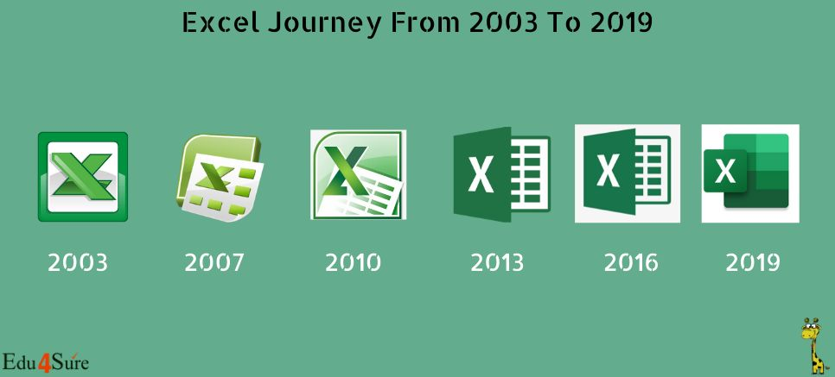

**Figure 2:Ms Excel**

## **3.1 Some Formulas in Excel**

1. Choose a cell.
2. To enter an equal sign, click the cell and type =.
3. Enter the address of a cell in the selected cell or select a cell from the list.
4. You need to enter an operator.
5. Enter the address of the next cell in the selected cell.
6. Press Enter.

The example below shows how we have used the multiplication formula manually with the ‘*’ operator.

Sample Formula: "=A2*B2"

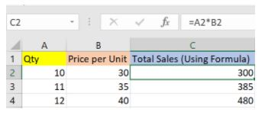

There are plenty of Excel formulas and functions depending on what kind of operation you want to perform on the dataset.

### **3.1.1 SUM**

The SUM() function, as the name suggests, gives the total of the selected range of cell values. It performs the mathematical operation which is addition. Here’s an example of it below:

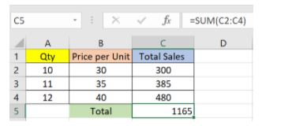

Sum "=SUM(C2:C4)"

As you can see above, to find the total amount of sales for every unit, we had to simply type in the function “=SUM(C2:C4)”. This automatically adds up 300, 385, and 480. The result is stored in C5.

### **3.1.2 AVERAGE**

The AVERAGE() function focuses on calculating the average of the selected range of cell values. As seen from the below example, to find the avg of the total sales, you have to simply type in:

AVERAGE =AVERAGE(C2, C3, C4)

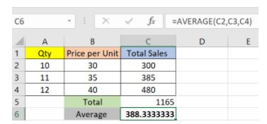

It automatically calculates the average, and you can store the result in your desired location.

### **3.1.3. COUNT**

The function [COUNT()](https://www.simplilearn.com/tutorials/excel-tutorial/count-in-excel) counts the total number of cells in a range that contains a number. It does not include the cell, which is blank, and the ones that hold data in any other format apart from numeric.

COUNT =COUNT(C1:C4)

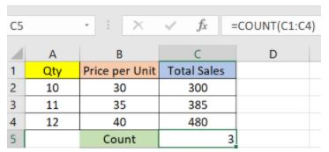

As seen above, here, we are counting from C1 to C4, ideally four cells. But since the COUNT function takes only the cells with numerical values into consideration, the answer is 3 as the cell containing “Total Sales” is omitted here.

If you are required to count all the cells with numerical values, text, and any other data format, you must use the function **‘COUNTA()**’. However**, COUNTA()** does not count any blank cells.

*To count the number of blank cells present in a range of cells,* ***COUNTBLANK()*** *is used.*

### **3.1.4 SUBTOTAL**

Moving ahead, let’s now understand how the subtotal function works. The SUBTOTAL() function returns the subtotal in a database. Depending on what you want, you can select either average, count, sum, min, max, min, and others. Let’s have a look at two such examples.

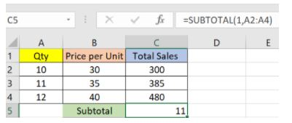

In the example above, we have performed the subtotal calculation on cells ranging from A2 to A4. As you can see, the function used is

SUBTOTAL =SUBTOTAL(1, A2: A4)

In the subtotal list “1” refers to average. Hence, the above function will give the average of A2: A4 and the answer to it is 11, which is stored in C5. Similarly,

“=SUBTOTAL(4, A2: A4)”

This selects the cell with the maximum value from A2 to A4, which is 12. Incorporating “4” in the function provides the maximum result.

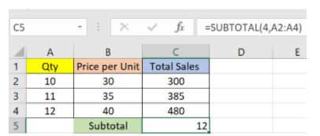

### **3.1.5 MODULUS**

The MOD() function works on returning the remainder when a particular number is divided by a divisor. Let’s now have a look at the examples below for better understanding.

* In the first example, we have divided 10 by 3. The remainder is calculated using the function

MODULUS =MOD(A2,3)

* The result is stored in B2. We can also directly type “=MOD(10,3)” as it will give the same answer.

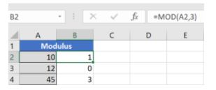

Fig: Modulus function in Excel

* Similarly, here, we have divided 12 by 4. The remainder is 0 is, which is stored in B3.

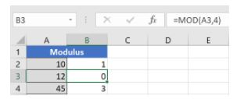

### **3.1.6 POWER**

The function “Power()” returns the result of a number raised to a certain power. Let’s have a look at the examples shown below:

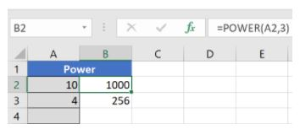

As you can see above, to find the power of 10 stored in A2 raised to 3, we have to type:  **Power =POWER (A2,3)**

### **3.1.7 CEILING**

Next, we have the ceiling function. The CEILING() function rounds a number up to its nearest multiple of significance.

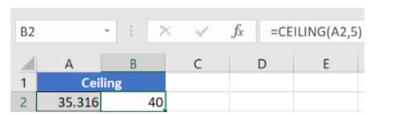

The nearest highest multiple of 5 for 35.316 is 40. [4]

## **3.2 Marksheet in Excel**

Suppose we have the following data for marks in various subjects.

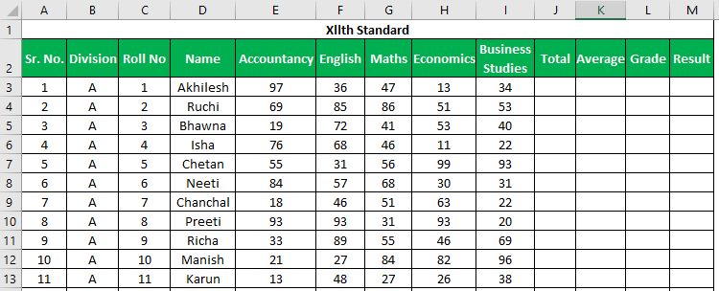

We want to find the total marks scored, an average of marks (this will also help us to give students grades), and a result on whether the student passed or failed.

To find out the total, we will use the **SUM function**

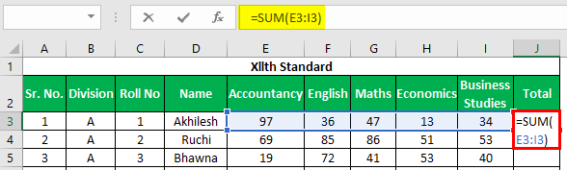

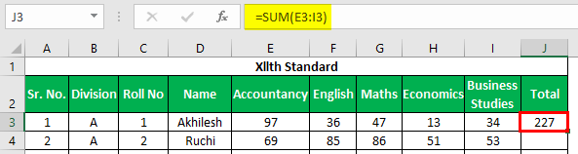The total will be:

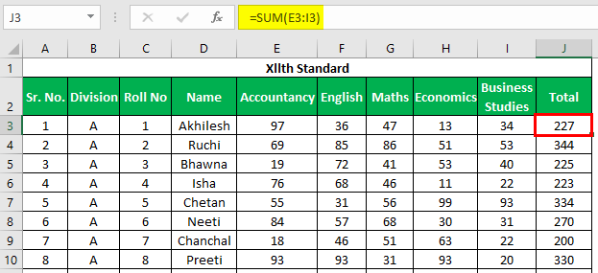Apply the above formula to all the remaining cells. We get the following result.

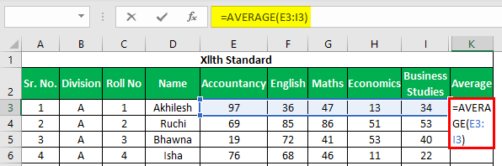For calculating average marks, we will use the AVERAGE function

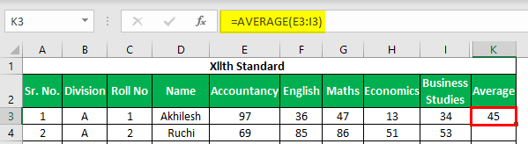The average will be –

Apply the above formula to all the remaining cells. We get the following result.

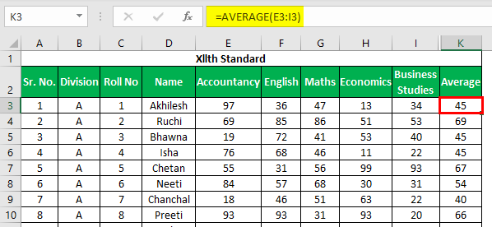

Now to find out the grade, we have the following criteria.

* If the student has scored average marks greater than or equal to 90, then the student will get a grade of S
* If the student has scored average marks greater than or equal to 80, then the student will get a grade of A+
* If the student has scored average marks greater than or equal to 70, then the student will get a grade A
* If the student has scored average marks greater than or equal to 60, the student will get a grade of B+.
* If the student has scored average marks greater than or equal to 35, then the student will get a grade of B
* If the student has scored average marks less than 35, the student will get a grade of F.

We will use the IF function in excel multiple times to apply these criteria.

We have used the following formula to evaluate the Excel mark sheet grades.

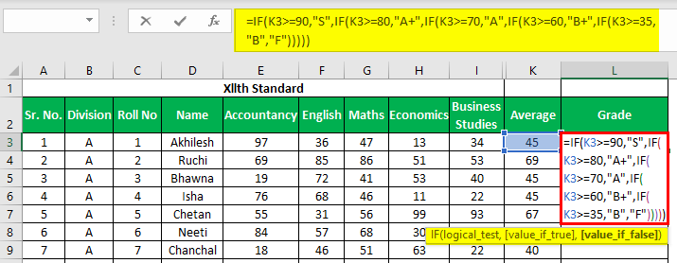

To find out whether a student is “PASSED” or “FAILED,” we have to apply the following criteria:

* If the student has scored greater than 200 as total marks and scored greater than 33 in all subjects, then the student is “PASSED.”
* If a student has scored less than 33 in 1 or 2 subjects and total marks are greater than 200, the student has got “ER” (Essential Repeat).
* If the student has scored less than 33 in more than 2 subjects or less than or equal to 200 as total marks, then the student is “FAILED.”

We need to evaluate several subjects where a student has scored less than 33. Then, we need to use the **COUNTIF function**to count numbers

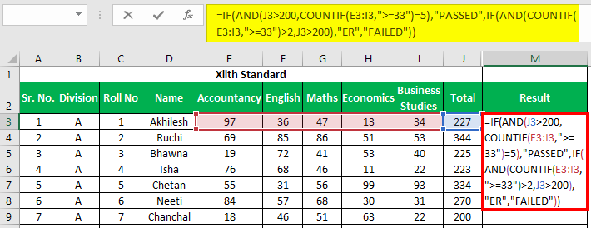

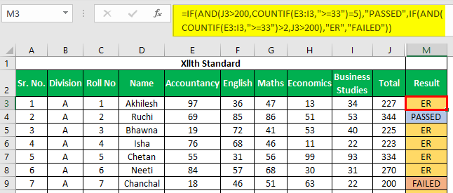Apply the above formula to all the remaining cells. We get the following result.

**Note:**

*We must ensure to close the brackets for the****IF function.***

*While specifying any text in the function, we must use double quotes (” “) as we have used while writing “Passed,” “Failed,” “ER,” etc. [5]*

# **Chapter 4: MS Dos**

MS-DOS, short for Microsoft Disk Operating System, is an early operating system developed by Microsoft. Unlike modern graphical user interfaces (GUIs), MS-DOS operates primarily through a command-line interface (CLI). Users interact with the system by typing commands at the prompt, typically represented by a blinking cursor on the screen.

MS-DOS utilizes a file system that organizes data on storage devices such as floppy disks and hard drives. The file system is hierarchical, with directories (folders) containing files and subdirectories. File and directory names adhere to the 8.3 format, which allows for a maximum of eight characters for the file name and three characters for the file extension.

**There are two types of command in MS-Dos:**

* **Internal Commands**: These are built-in functions of Ms-DOS Operating System, It can be used directly from cmd. Examples include `DIR`, `CD`, `CLS`, `TIME`, and `DATE`.
* **External Commands:** These commands are stored in separate executable files (.exe) and require their own files to run. When you type an external command, MS-DOS loads the corresponding program into memory. Examples include `FORMAT`, `CHKDSK`, `DISKCOPY`, and `XCOPY`.

**Basic Commands**: MS-DOS provides a set of built-in commands for performing various tasks. *Some fundamental commands include:*

**DIR**: Lists the contents of a directory.

**CD**: Changes the current directory.

**COPY:** Copies files from one location to another.

**DEL:** Deletes files.

**FORMAT**: Formats a disk.

**CHKDSK:** Checks a disk for errors.

**REN**: Renames files.

## **4.1 Fun Commands**

### **4.1.1 Title**

This command changes the title of the command prompt.

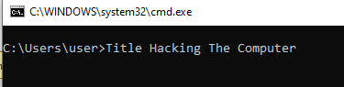

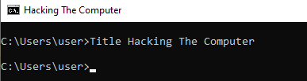

### **4.1.2 Prompt**

This command changes the prompt text,

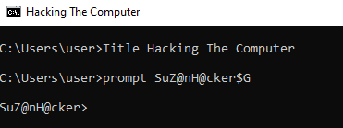

### **4.1.3 Color**

This command changes the color of the text and background,

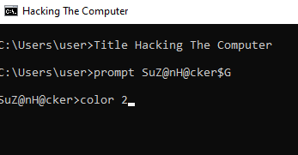

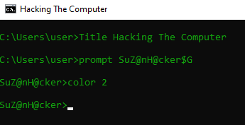

**NOTE :** you can get information about how to use command by using command name followed by /.

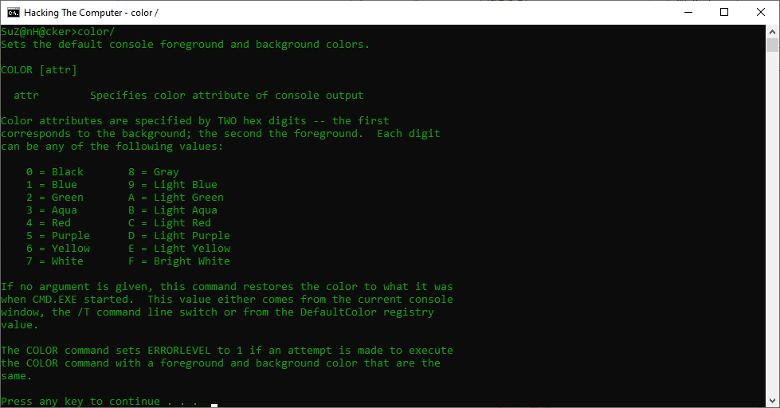

## **4.2 Some Internal Commands**

### **4.2.1 CLS**

This commands clears the screen

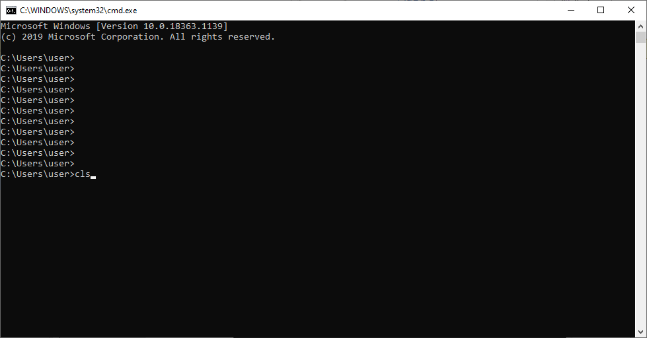

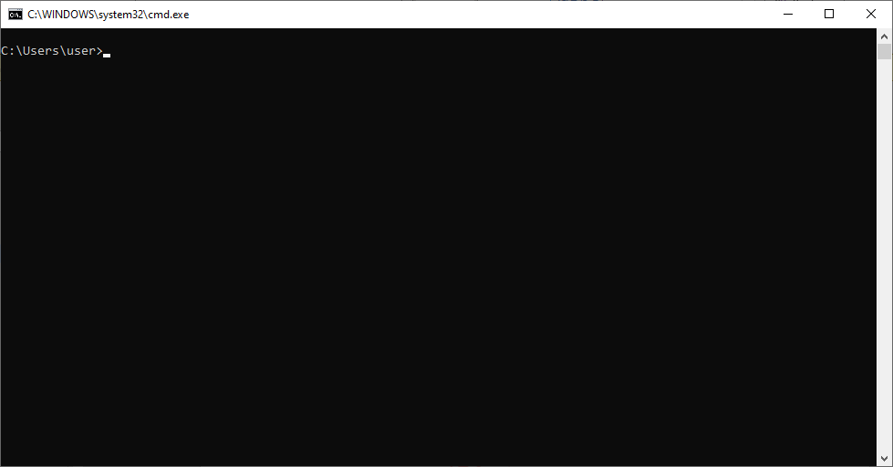

### **4.2.2 Date and Time**

This command shows the system date and time and allows you to edit them too.

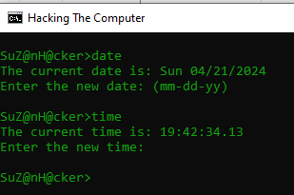

### **4.2.3 Md or mkdir**

this command helps user to create the directory. ie folder;

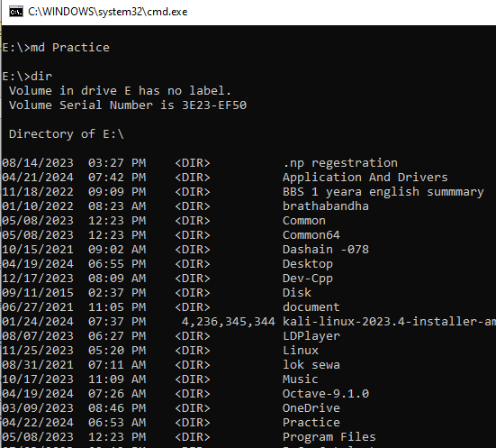

### **4.2.4 Copy**

this command is usually used to create the text file.

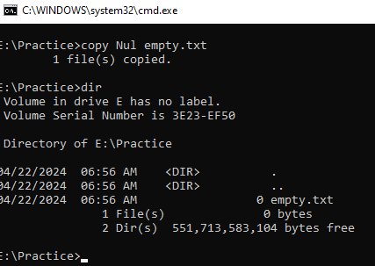

### **4.2.5 Type and echo**

Type command display the content of the text or file and echo command is used to overwrite the comtents of text file.

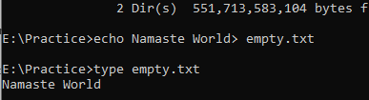

### **4.2.6 Ren or Rename**

This command helps to rename the file or directory.

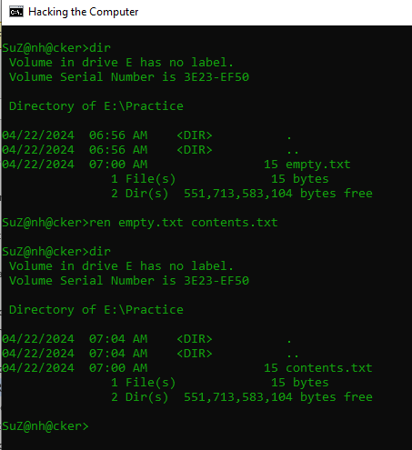

### **4.2.7 dir**

This command displays contents of the directory that we currently are in.

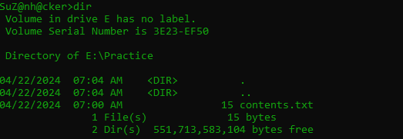

### **4.2.8 del**

This command deletes one or more files from the current directory

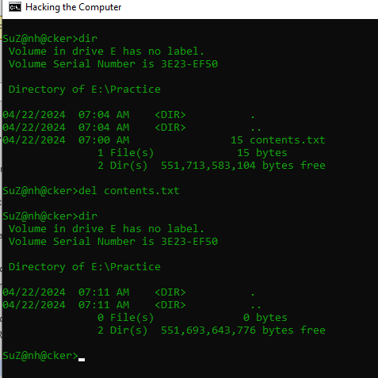

### **4.2.9 RD**

This command is used to remove the empty directory.

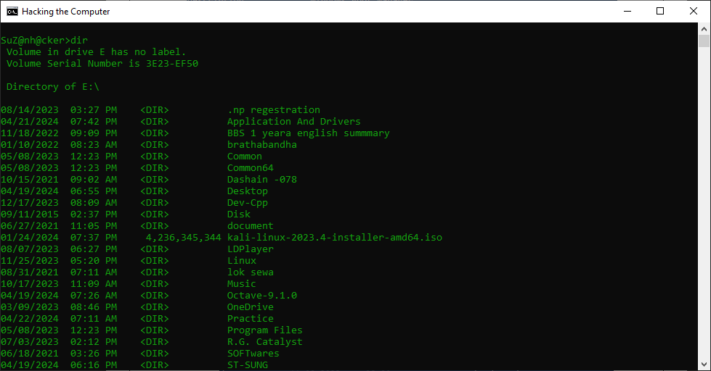

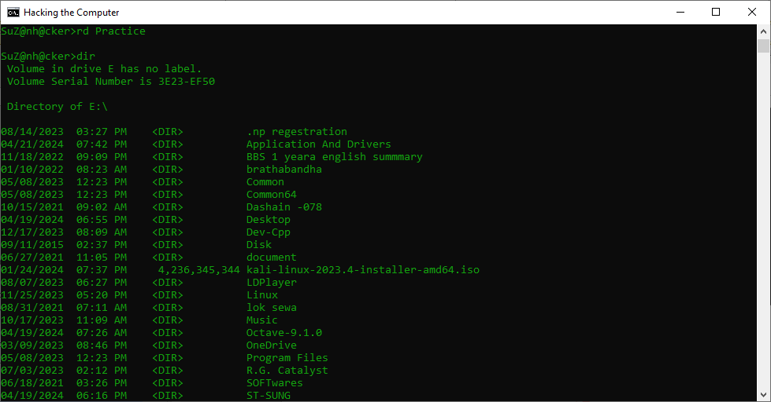

### **4.2.10 vol and ver**

vol command is used to display the disk volume label and its serial number, ver command tells the version of the current operating system.

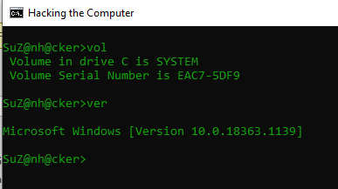

## **4.3 Some External Commands**

### 4.3.1 Format

This command is used to format a disk with windows

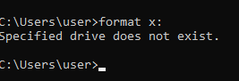

### **4.3.2 DISKCOPY**

This command is used to copy the contents of one fllopy to another

### **4.3.3 XCOPY**

This command copies all the files and directories.

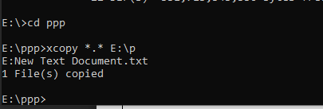

### **4.3.4 CHKDSK**

This command is an abbebratation of check disk.it is used to identify and resolves errors on the hard disk. it opens the utility that checks the hard disk for any errors.

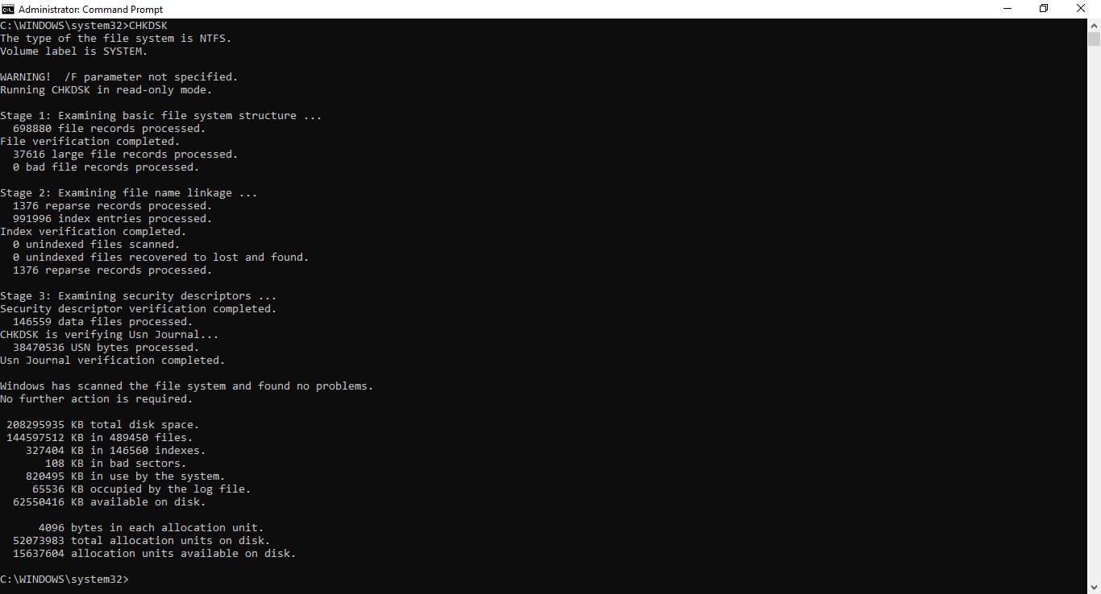

### **4.3.5 TREE**

This Command is used to show all the files of the drive.

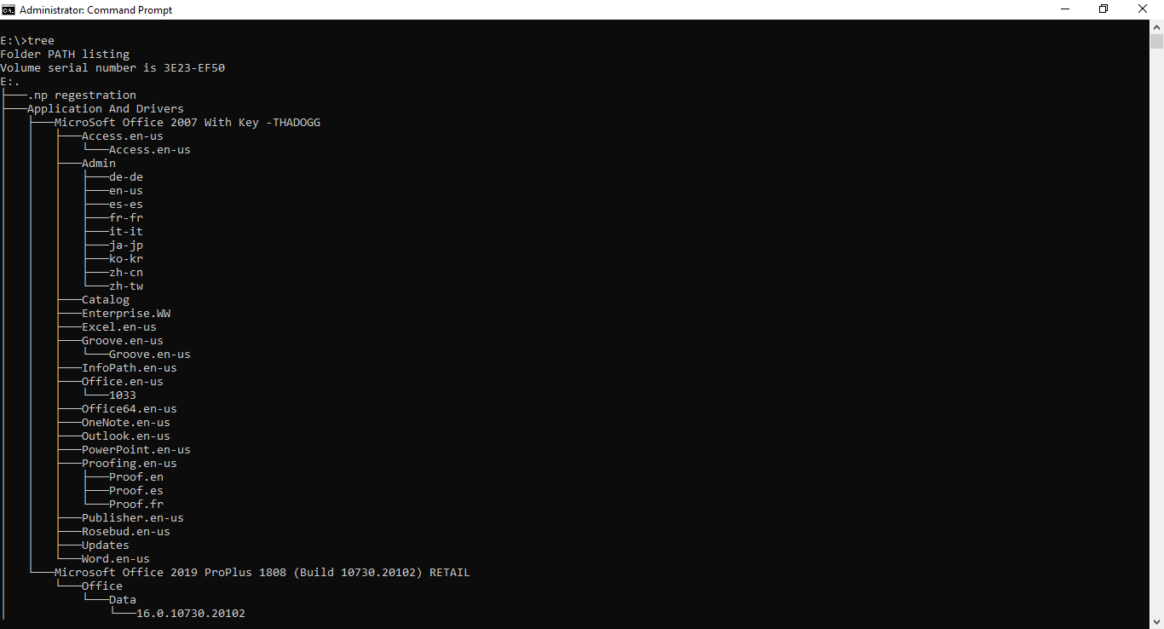

### **4.3.6 More**

This command is used to display the content of a file one page at a time.

### **4.3.7 ATTRIB**

This command allows user to change the attributes of the files. by using this command a user can easily hide/display or do any change to a file.

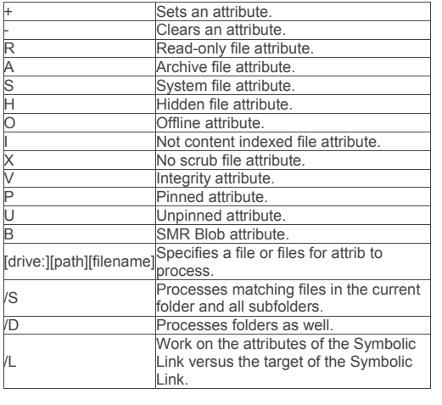

# **Chapter 5: Photoshop**

Adobe Photoshop is a powerful graphics editing software widely used by designers, photographers, artists, and hobbyists. It allows users to manipulate and enhance digital images with a vast array of tools and features. It was originally developed by the American brothers Thomas and John Knoll in 1987 and then later Adobe.Inc brought the license to distribute in 1988. It is available for both macOS and Windows operating systems. Photoshop is used to create or edit images, posters, banners, logos, invitation cards, and various types of graphic designing work.The default file format of photoshop is .PSD, i.e., Photoshop document. It provides various tools for designing and editing. [6]

## **5.1 Tools in Photoshop**

As we know, Photoshop provides various types of tools. So, some of the commonly used tools are:

### **5.1.1 Move tool**

This tool is used to move the selected area or the entire layer simply by dragging it with your mouse or using your keyboard arrow keys. Using this tool, you can move the selected area anywhere in the image according to your requirements. By default, this tool moves the selected area and if the area is not selected, then it will move the entire layer. You can select move tool from the tool palette or just hold down the Ctrl key in windows and Command key in mac, to activate it.

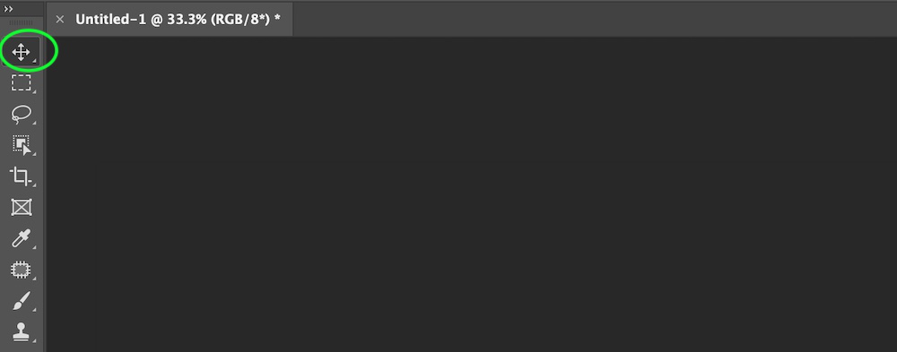

**Example:**

**Step 1:** Open an image in Photoshop.

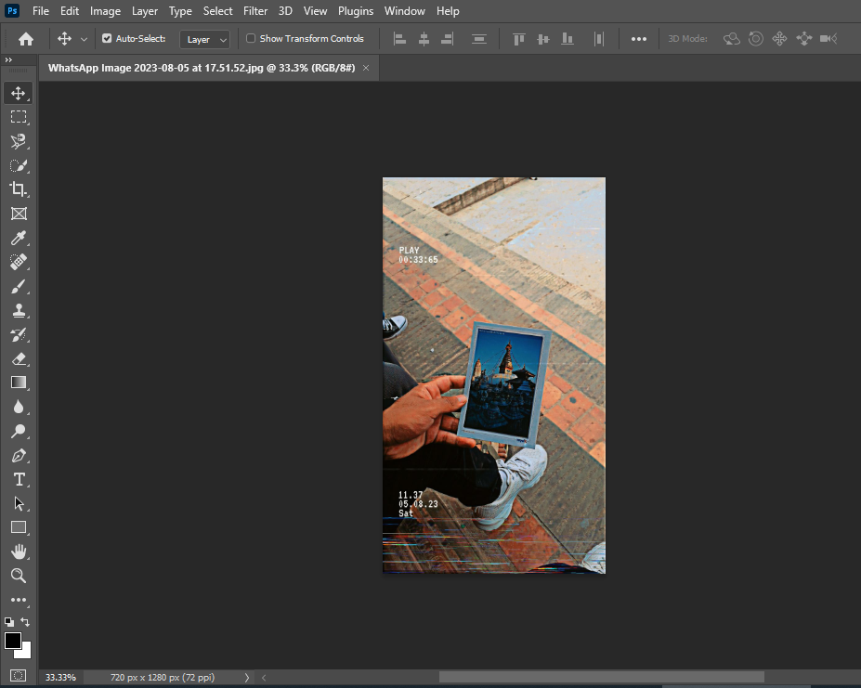

**Step 2:** Select the part of the image that you want to move using any selection tool.

**Step 3:**Select the Move tool from the tool palette.

**Step 4:**After selecting the move tool just hold the left click on your mouse and drag the selected section. And put that selected part to anywhere in the image. That’s all you have to do to use this tool.

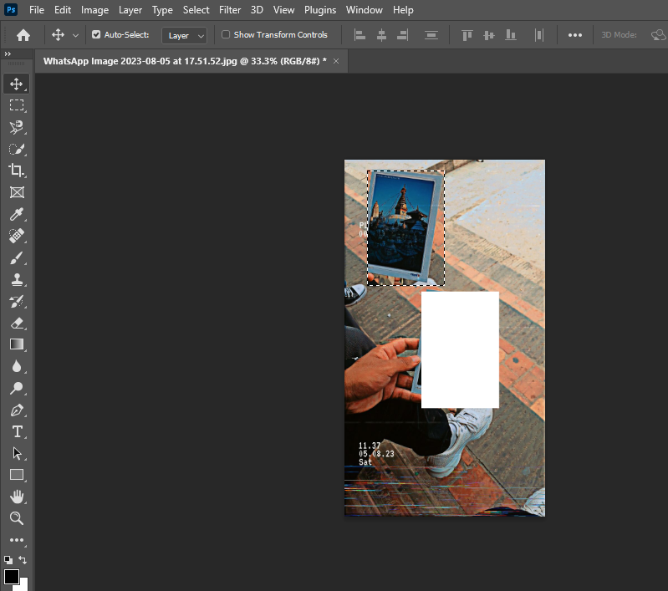

### **5.1.2 Rectangular Marquee tool**

This tool is also a selection tool. Using the Rectangular Marquee tool, you can make a rectangular-shaped selection or geometric shapes. You can select the Rectangular Marquee tool from the tool palette.

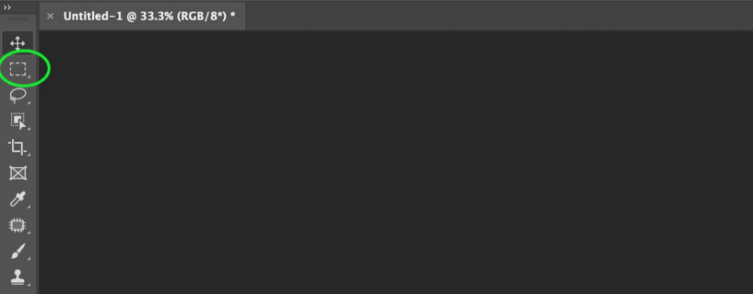

**Example:**

**Step 1:** Open the image in Photoshop.

**Step 2:**Select the Rectangular Marquee tool from the tool palette.

**Step 3:**After selecting the Rectangular Marquee tool just hold the left click on your mouse and drag on the image layer, then it will create a rectangular selection on the image layer and that’s all you have to do to use this tool.

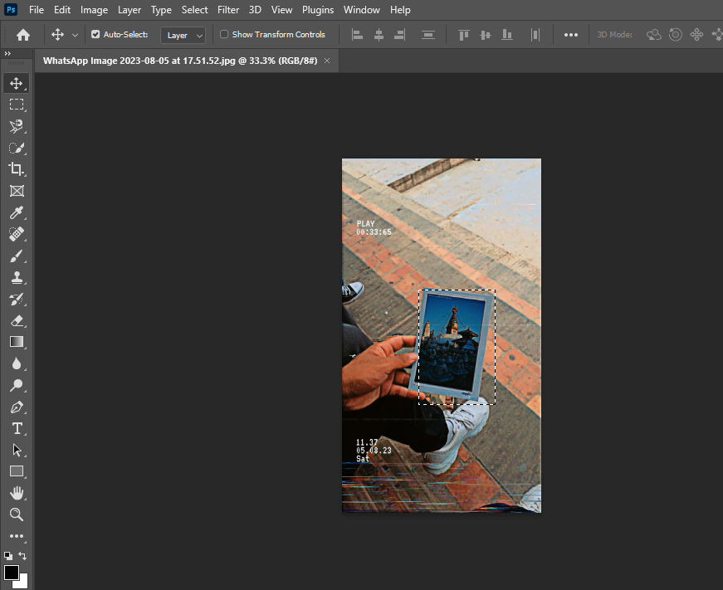

### **5.1.3 Lasso Tool**

This tool is also a selection tool. This tool allows you to draw a freehanded choice border around the object you wish to pick out in your image. You can select the Lasso Tool from the tool palette or the shortcut for the lasso tool is  L.

**Example:**

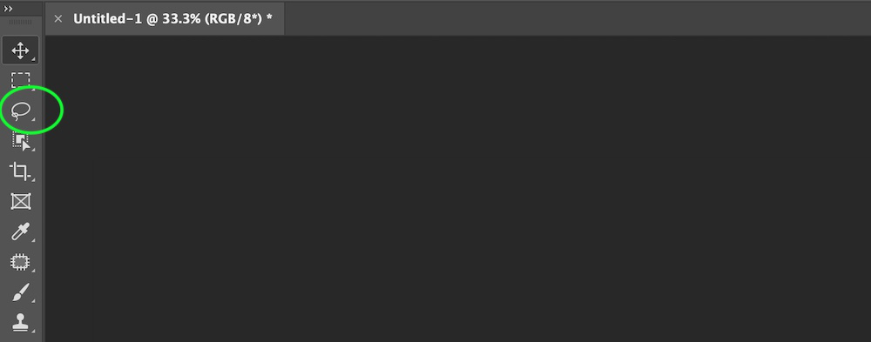

**Step 1:** Open the image in Photoshop.

**Step 2:**Select the Lasso Tool from the tool palette.

**Step 3:**After selecting the Lasso tool now click on the image from where you want to draw and just draw a selection with the help of the cursor just like drawing on paper with a pencil by pressing the mouse pointer. On releasing the pointer our drawing will turn into a selection like as shown in the below image and that’s all you have to do to use this tool.

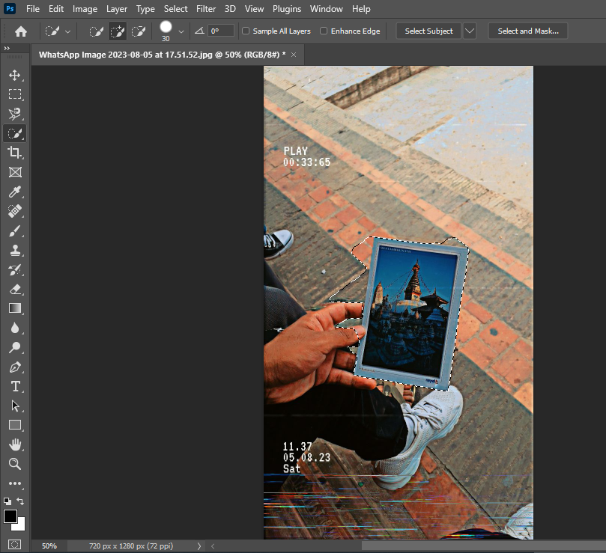

### **5.1.4 Crop Tool**

This tool allows you to choose an area of an image and discard everything outside this area. It also straightens photos in Photoshop. The cropping process does not alter the size of the image content. It is a non-destructive tool, and you can also choose to retain the cropped pixels to optimize the crop boundaries later. You can select the Crop Tool from the tool palette.

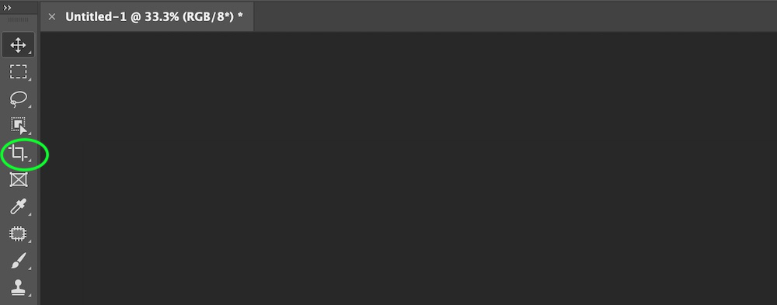

**Example:**

**Step 1:** Open the image in Photoshop.

**Step 2:**Select the Crop Tool from the tool palette.

**Step 3:**After selecting the crop tool you will get a rectangular box on your image using this rectangular box you can adjust the size of the area that your want to crop and that’s all you have to do to use this tool.

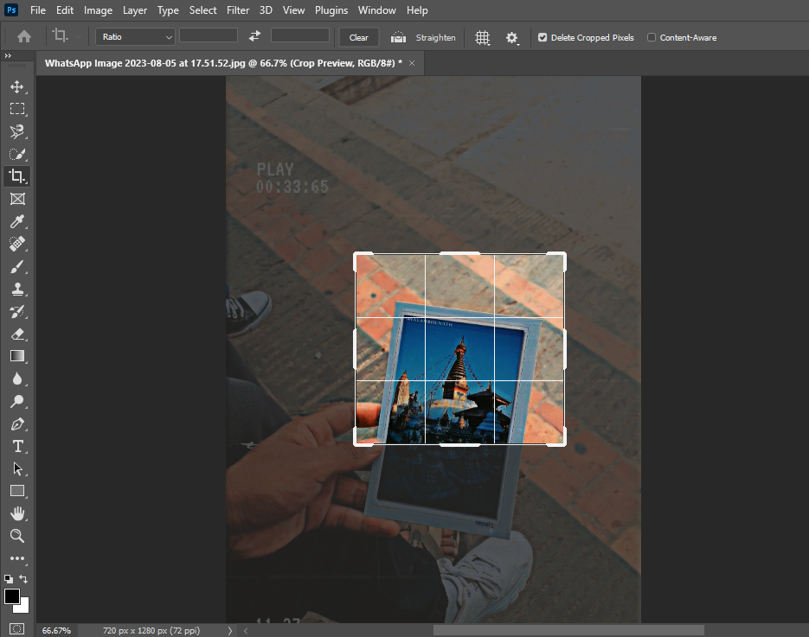

### **5.1.5 Object Selection Tool**

It is also a selection tool. It simplifies the way you’ll be able to choose an associate object or maybe a part of an associate object in a picture. Photoshop already has a Subject choice tool. However, it’s supposed to pick out all subjects within the image. This tool lets you identify the object by making a rough selection around the image. Once you have drawn the selection, it automatically shrink-wraps the selection to the edges of your object. You can select the Object Selection Tool from the tool palette.

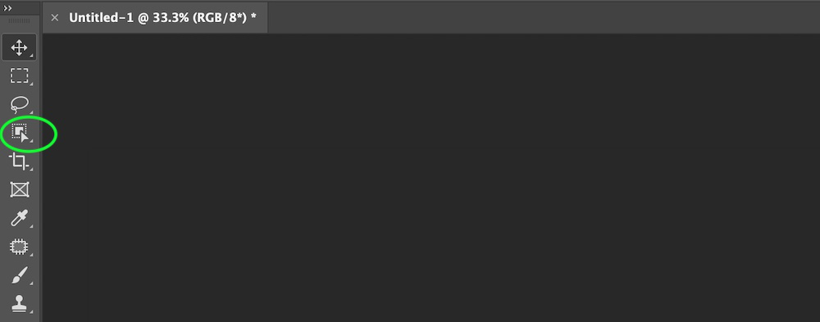

**Example:**

**Step 1:** Open the image in Photoshop.

**Step 2:**Select the Object Selection Tool from the tool palette.

**Step 3:**After selecting the Object Selection tool, draw a rectangle box using this tool and it will automatically detect the object from the image like as shown in the below image and that’s all you have to do to use this tool.

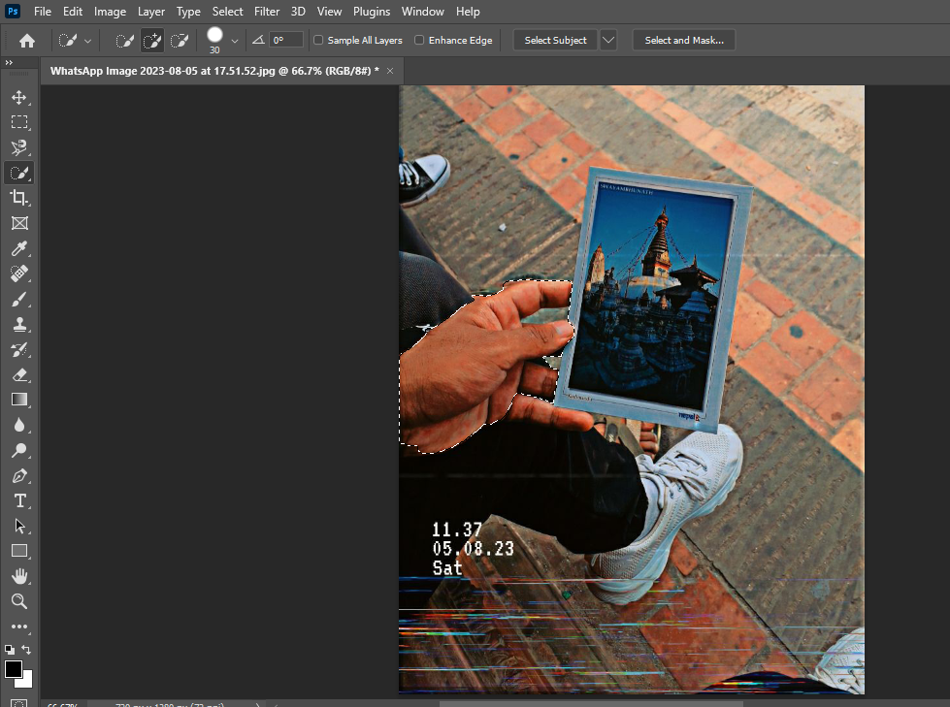

### **5.1.6 Frame Tool**

This tool allows you to draw placeholder frames that you will simply fill with pictures. You can simply choose the Frame Tool from the Tools panel or press K from the keyboard.

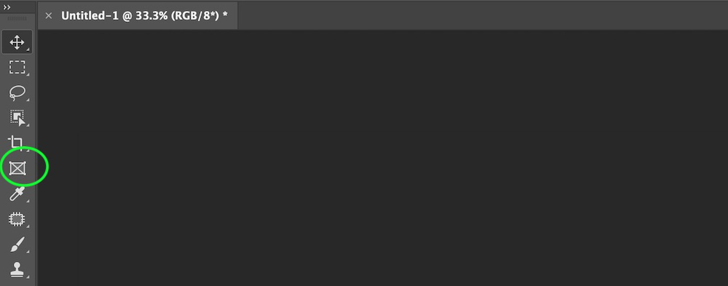

**Example:**

**Step 1:** Open Photoshop.

**Step 2:**Select the Frame Tool from the tool palette.

**Step 3:**After selecting the frame tool, draw a frame and in that frame, you can add an image according to your requirement.

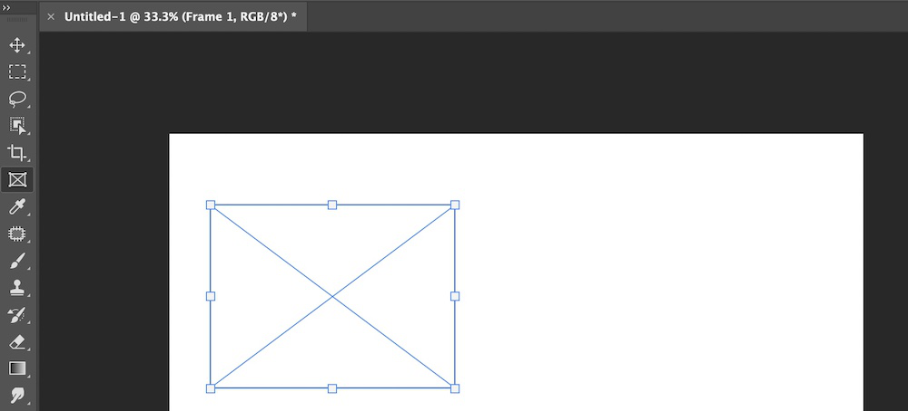

### **5.1.7 Eyedropper Tool**

In Adobe Photoshop, the eyedropper tool is one of the easy-to-use tool. It is generally used by digital painters, editors, and other people who use Photoshop. This tool is used to select a color from an image or any Photoshop document and add them to your Swatches panel.

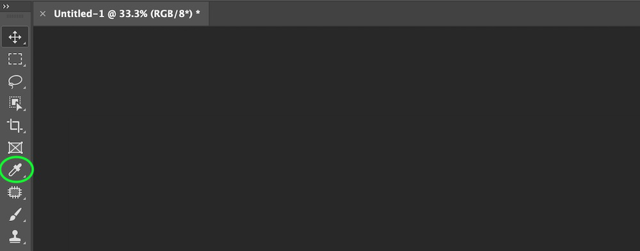

**Example:**

**Step 1:** Open the image in Photoshop.

**Step 2:**Select the eyedropper Tool from the tool palette.

**Step 3:**After selecting the eyedropper tool, put your mouse over the image and click to pick the sample image. A ring will appear on the screen like as shown in the below image and that’s all you have to do to use this tool.

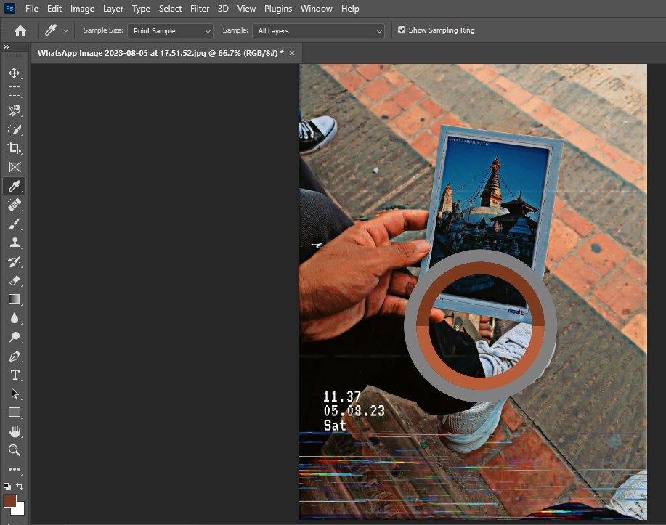

### **5.1.8 Patch Tool**

This tool is used to remove spots and marks from the images. Or in other words, It is used for painting and retouching images like removing big scar or an oversized space of skin. This tool is generally hidden behind the Healing Brush tool within the Tools panel.

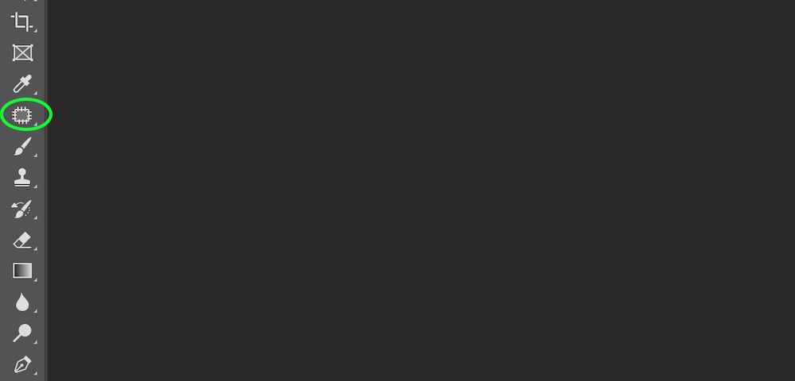

**Example:**

**Step 1:** Open the image in Photoshop.

**Step 2:**Select the Patch Tool from the tool palette.

**Step 3:**After selecting the patch tool, draw a circle on the area that you want to remove and drag that circle to the new area, and when you release your mouse you will see the changes. Like as shown in the below image here we remove the hole from the leaf using this tool.

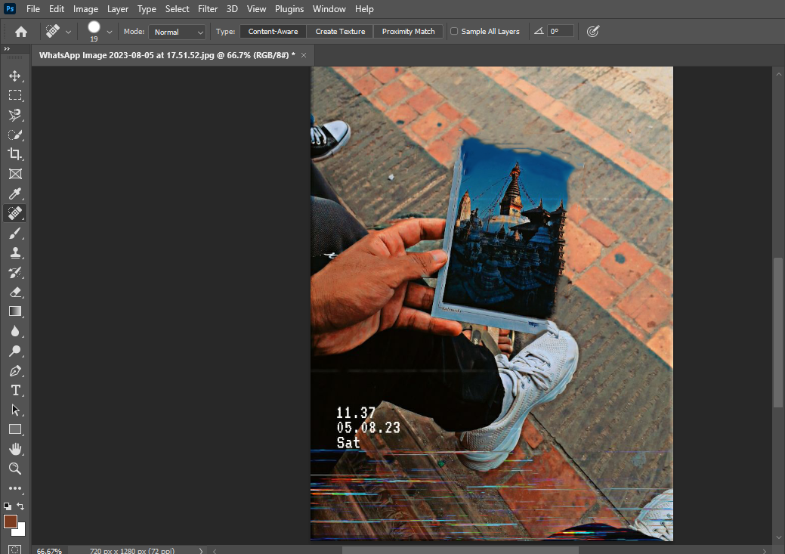

### **5.1.9 Brush Tool**

The brush tool is the most commonly used tool in Photoshop almost every Photoshop user uses this tool. This tool is just like the brush in the real world. It is used to paint canvas in Photoshop.

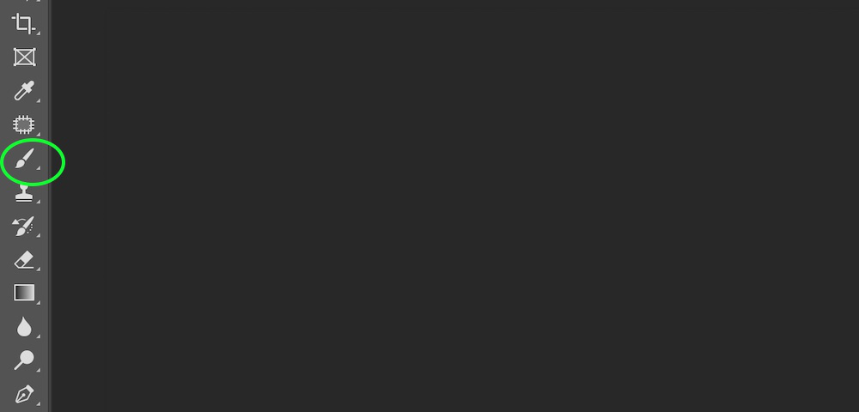

**Example:**

**Step 1:** Open the image in Photoshop.

**Step 2:**Select the Brush Tool from the tool palette.

**Step 3:**Now we select green color(or any color) from the palette.

**Step 4:**After selecting the brush tool just hold the left click on your mouse and drag over the image. It will start painting and that’s all you have to do to use this tool.

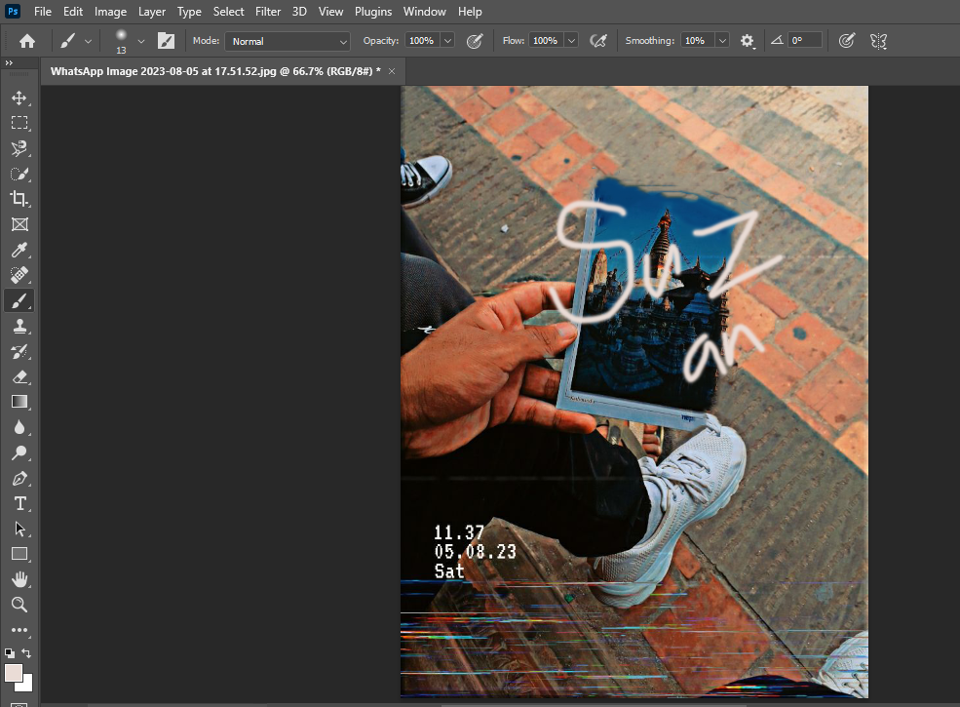

### **5.1.10 Clone Stamp Tool**

This tool is helpful once you have to copy the same detail and color from one part of a picture to a different space image. With this tool, you’ll be able to use an associated empty layer to keep your retouching break away the most image

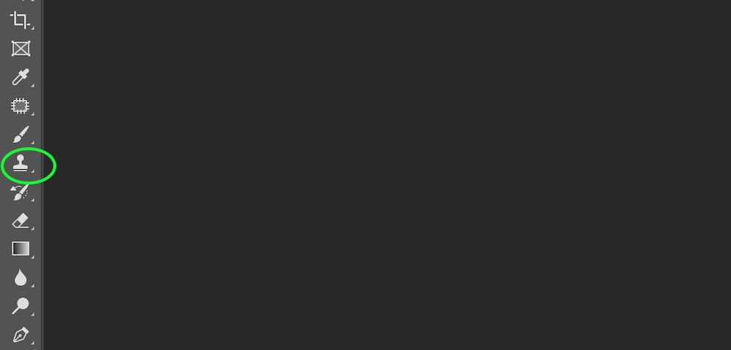

**Example:**

**Step 1:** Open two images in Photoshop.

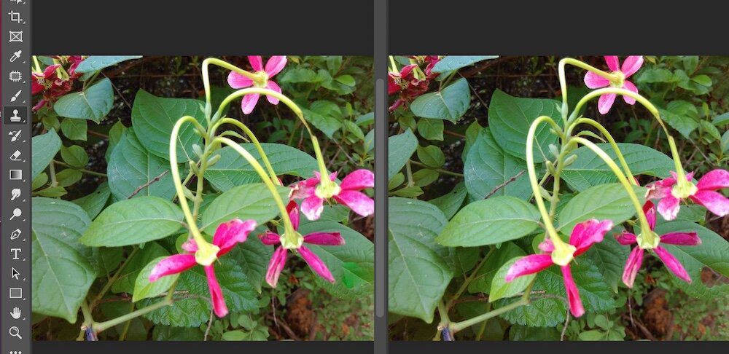

**Step 2:**Select the clone stamp tool from the tool palette.

**Step 3:**After selecting clone stamp tool, now position the cursor over the section that you want to clone(in image 1) and then press Alt key in windows or option key in mac to define the clone source. After defining the clone source now place your cursor on the section(in image 2) where your want to paint the cloned pixel and then start painting.

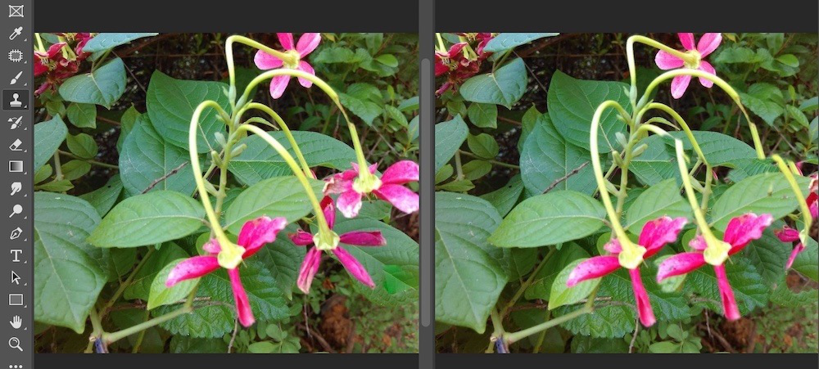

### **5.1.11 History Brush Tool**

This brush uses a previous state of a picture. The tool makes a replica of the image because it was during a previous state and so uses this copy’s content to color with.

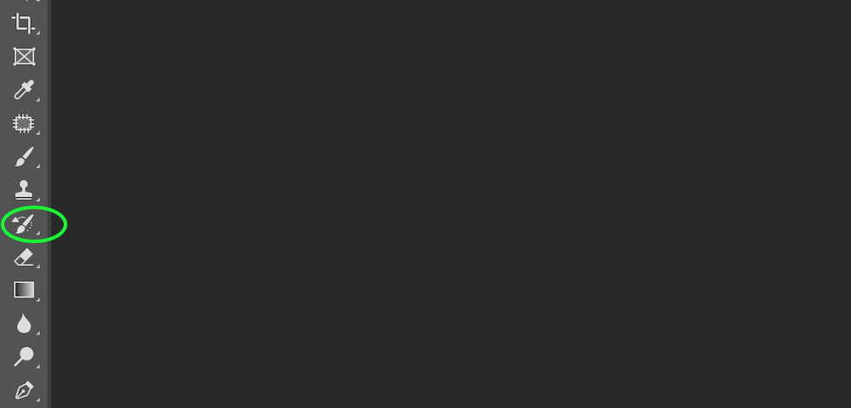

**Example:**

**Step 1:** Open the image in Photoshop.



**Step 2:**Select the history brush Tool from the tool palette.

**Step 3:**After selecting history brush Tool just hold the left click on your mouse and drag over the image. It will give the previous state of the image and that’s all you have to do to use this tool.

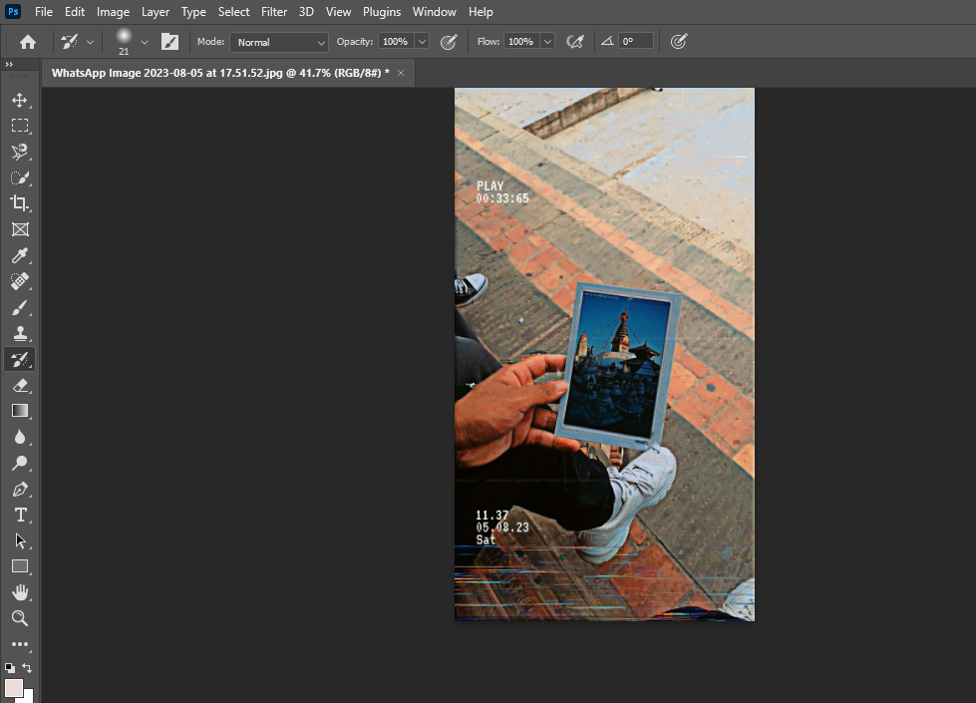

### **5.1.12 Eraser Tool**

This tool is the most commonly used tool in Photoshop. It will create clear constituents or match them to the background image color. Or in other words, this tool is used to change the color of the pixels either in the background color or to a transparent.

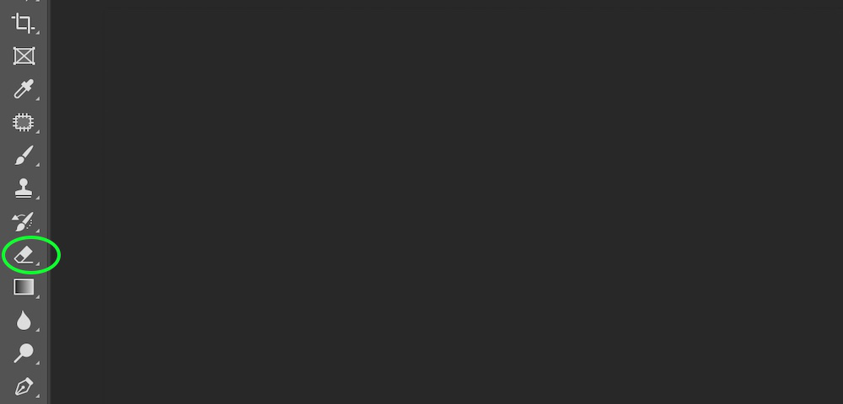

**Example:**

**Step 1:** Open Photoshop.



**Step 2:** Select the eraser tool from the tool palette.

**Step 3:**After selecting the eraser tool, just simply hold left click of your mouse and erase the area that you want to remove from your image like as shown in the below image:



### **5.1.13 Gradient Tool**

This tool allows you to form a gradual transition between two or additional colors by exploiting the Gradient Tool. This tool may be applied to any designated space of a picture. If no space is chosen, the gradient is applied to the whole layer.

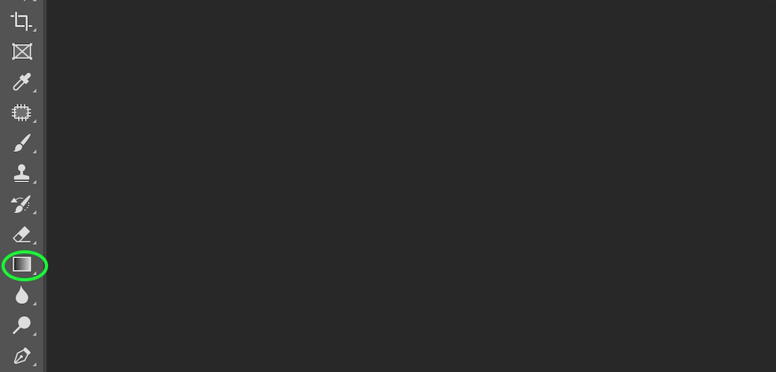

**Example:**

**Step 1:** Open Photoshop.

**Step 2:** Select the gradient tool from the tool palette and apply the gradient effect on your image.



### **5.1.14 Blur Tool**

The Blur Tool is employed to color a blur impact, each stroke made exploitation. This tool can scale back the distinction between affected pixels and make them seem blurred. The context-sensitive choices Bar, typically placed at the highest of your space, can show all relevant choices associated with the Blur Tool.

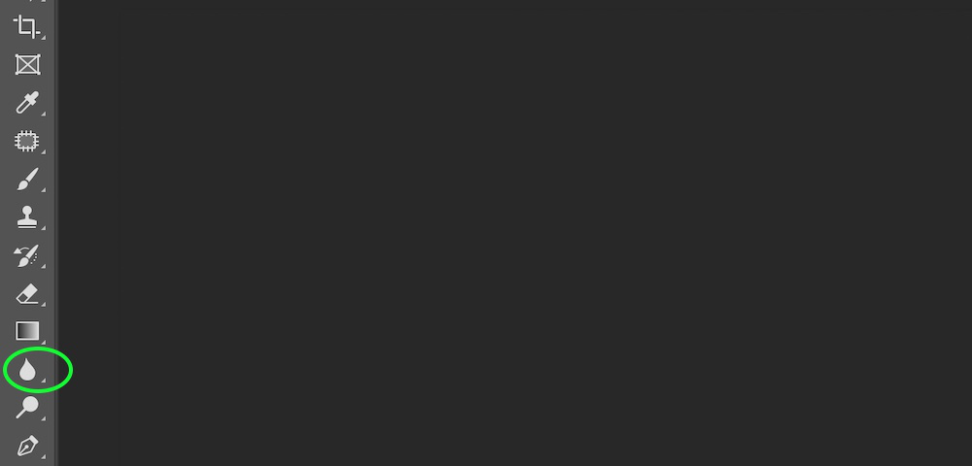

**Example:**

**Step 1:** Open the image in Photoshop.

**Step 2:**Select the Blur Tool from the tool palette.

**Step 3:**After selecting blur Tool just hold the left click on your mouse and drag over the image. It will blur the image and that’s all you have to do to use this tool.

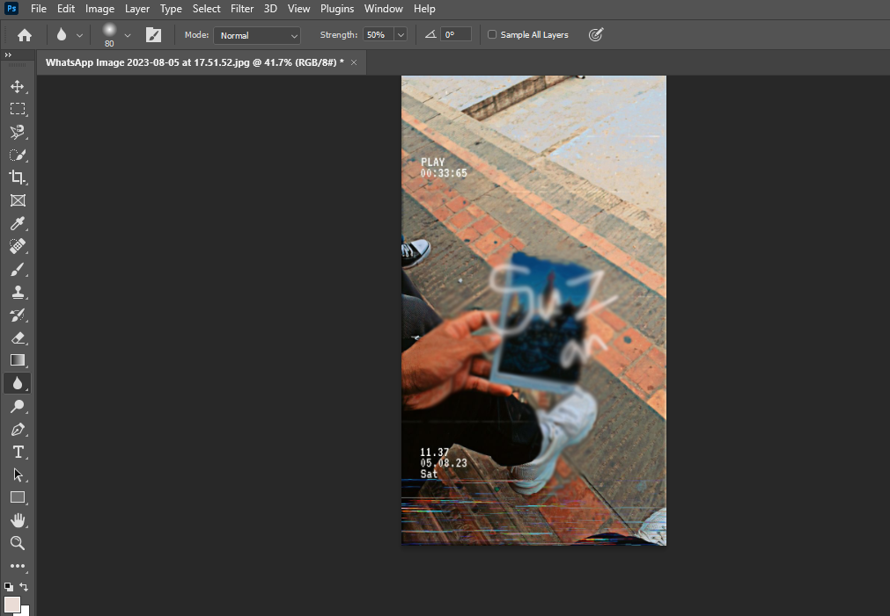

### **5.1.15 Dodge Tool**

The Dodge tool and also the Burn tool lighten areas of the image. Dodge tool happen supported a room technique for control exposure at specific areas of a print.

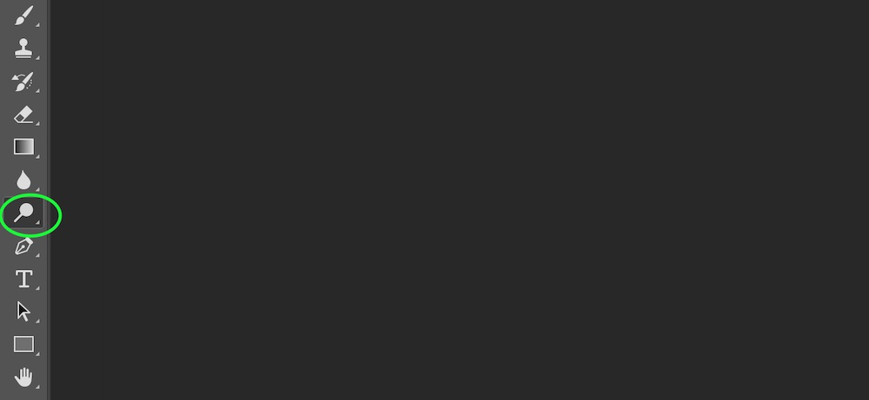

**Example:**

**Step 1:** Open the image in Photoshop.

**Step 2:**Now select the area in the image using any selection tool, here I use the object selection tool.

**Step 3:**Select the Dodge Tool from the tool palette.

**Step 4:**After selecting Dodge Tool just hold the left click on your mouse and drag over the image. It will lighten the darker area in the image and that’s all you have to do to use this tool.

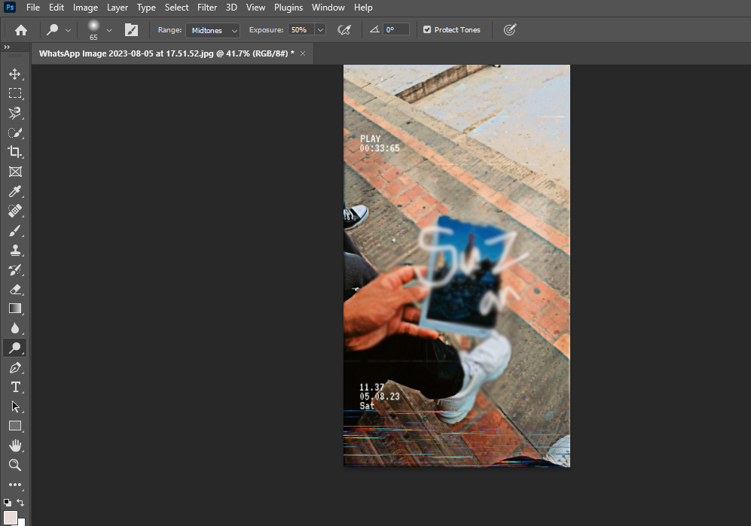

# **References**

|  |  |
| --- | --- |
| [1] | M. K. K. H. K. R. R. Dipak Pudasdaini, Computer Science-I, Buddha Publication Pvt. Ltd.. |
| [2] | "Bibliography.com," [Online]. Available: https://www.bibliography.com/how-to/how-to-add-or-insert-citations-in-word-quickly/. |
| [3] | "Gadgetsnow," [Online]. Available: https://www.gadgetsnow.com/faqs/what-is-ms-word-and-its-features/articleshow/84464446.cms. |
| [4] | "Simplilearn," [Online]. Available: https://www.simplilearn.com/tutorials/excel-tutorial/excel-formulas. |
| [5] | "WallStreetMojo," [Online]. Available: https://www.wallstreetmojo.com/marksheet-in-excel/. |
| [6] | "greeksforgreeks," [Online]. Available: https://www.geeksforgeeks.org/beginners-guide-to-photoshop-tools/. |